
American International University-Bangladesh (AIUB)
Department of Computer Science
Faculty of Science & Technology (FST)
"Personalized Healthcare Assistant -Tracks Patient Health Records, Medications, and Appointment Reminders"

A Software Engineering Project Submitted
By

Semester: Fall_24_25 |  | Section: M | Group Number: 5
SN | Student Name | Student ID | Contribution (CO3+CO4) | Individual  Marks
1. | Abdullah Al Tasnim Mahim | [22-49699-3] | 20%
2. | Md.Arshad Islam | [22-47050-1] | 20%
3. | Mahamodol Hasan Taj | [22-47271-1] | 20%
4. | Md.Omar Faruk | [22-49189-3] | 20%
5. | Omar Faruq Mirdha | [22-46296-1] | 20%

The project will be evaluated for the following Course Outcomes

CO3: Select appropriate software engineering models, project management roles, and their associated skills for the complex software engineering project and evaluate the sustainability of developed software, taking into consideration the societal and environmental aspects | Total Marks
Appropriate Process Model Selection and Argumentation with Evidence | [5 Marks]
Evidence of Argumentation Regarding Process Model Selection | [5Marks]
Analysis of the impact of societal, health, safety, legal, and cultural issues | [5Marks]
Submission, Defense, Completeness, Spelling, grammar, and Organization of the Project report | [5Marks]
CO4: Develop a project management plan to manage software engineering projects following the principles of engineering management and economic decision process | Total Marks
Develop the project plan, its components of the proposed software products | [5Marks]
Identify all the activities/tasks related to project management and categorize them within the WBS structure. Perform detailed effort estimation correspond with the WBS and schedule the activities with resources | [5Marks]
Identify all the potential risks in your project and prioritize them to overcome these risk factors. | [5Marks]
CO5: Perform as an effective team member or leader in diverse team settings and solve multi-disciplinary problems in the computer science and engineering domain | Total Marks
Taking project responsibility: perform assigned tasks on time independently | [5Marks]
Contribution to project group meetings, sharing fruitful ideas | [5Marks]
Positive attitude towards group work, collaboration, compromise, helping others to understand their project work responsibility | [5Marks]
Showing respect and value towards other team member's opinion | [5Marks]

Description of Student’s Contribution in the Project work

Student Name: Abdullah Al Tasnim Mahim
Student ID: 22-49699-3
Contribution in Percentage (%): 20
Contribution in the Project:
Project Proposal Planning,
Project Management Roles,
Functional Requirements (1 to 12),
Nonfunctional Requirements (1 to 9),
Activity Diagram,
UI/UX Design & Descriptions,
Test Case (1 to 5),
WBS,
Timeline Chart,
Gantt Chart,
Risk table & analysis

___________________
Signature of the Student

Student Name: Md Arshad Islam
Student ID: 22-47050-1
Contribution in Percentage (%): 20
Contribution in the Project:
Background to the problem,
Why Agile is the Best Choice,
Functional Requirements (13 to 24),
Nonfunctional Requirements (10 to 22),
Sequence Diagram,
Test Case (6 to 10),
Risk Table & Analysis

___________________
Signature of the Student

Student Name: Mahamodol Hasan Taj
Student ID: 22-47271-1
Contribution in Percentage (%): 20
Contribution in the Project:
Proposed Solution,
Project Management Responsibilities,
Functional Requirements (25 to 36),
Nonfunctional Requirements (23 to 30),
Class Diagram,
Test Plan,
Test Case (11 to 15),
COCOMO,
Risk Table & Analysis

___________________
Signature of the Student

Student Name: Md.Omar Faruk
Student ID: 22-49189-3
Contribution in Percentage (%): 20
Contribution in the Project:
Target Group & Benefits Evaluation,
Choosing the Optimal Software Engineering Process Model,
Functional Requirements (37 to 48),
Nonfunctional Requirements (31 to 38),
Use Case Diagram,
Test Case (19),
EVA,
Risk table & analysis

___________________
Signature of the Student

Student Name: Omar Faruq Mirdha
Student ID: 22-46296-1
Contribution in Percentage (%): 20
Contribution in the Project:
Existing Solutions & Improvement Comparison,
Design Specification,
Functional Requirements (49 to 60),
Nonfunctional Requirements (39 to 49),
Case study,
Test Case (16 to 18),
Risk table & analysis

___________________
Signature of the Student

PROJECT PROPOSAL

Background to the Problem
- Write the background description that helps putting your project into the right context of a problem domain and gives everyone involved a common view of the project.
- What is the root cause of this problem? Why this problem is so important to consider?.

Solution to the Problem
- Describe what is your project/thesis objective? What solutions are you going to provide to solve the above-mentioned problems?
- What are the solutions you are going to propose to deal with the problem? why is this solution is particularly appropriate to solve the problem? Is the solution feasible to the meet the business objective?
- Describe the basic functionalities of your proposed solution that makes the best use of state‐of‐art technology and produced a significant result that is likely to have a major impact on societal, health, safety, legal and cultural issues. Provide a deep insight that demonstrate and preset a creative solution to the real‐life problem.
- Describe the target group of users of your solution? And how they will be benefited by your proposed solution to the problem?
- Describe the contribution of your project to the development of scientific results that is identified and well documented.
- Provide a literature review on what are the other studies that have discussed the same topic of yours in the literature and explain how your study has utilized and extended the problems of existing studies.
- Provide a description of all the existing studies presented in the problem area. What are the existing software solutions (for project) are available to solve the aforementioned problems?
- What are the existing software solutions are available to solve the aforementioned problem? And how your proposed solution is going to extend them in providing more benefits to the users?

SOFTWARE DEVELOPMENT LIFE CYCLE

Process Model
- Provide an analysis regarding the nature and environment of the software that you are going to develop and select the best suitable method(s) to develop the software.
- Present your arguments based on your analysis about why your selected method(s) is the best choice among all other methods to develop your proposed software.
- Presents sufficient amount of evidence to support argument for your model selection in developing your proposed solution.

Project Role Identification and Responsibilities
- Identify all the roles/stakeholder in the software/project management activities in software development.
- Describes the responsibilities of the role in the software development.

Rubric for Project Assessment (CO3)
Criteria | Marks distribution (Max 3X5= 15) |  |  |  | Acquired  Marks
 | Inadequate (1-2) | Satisfactory (3) | Good (4) | Excellent (5)
Selection of Software Engineering Models | Does not articulate a position or argument of choosing appropriate model. Does not present any evidence to support the arguments for the choice of the model | Articulates a position or argument for choosing models that is unfocused or ambiguous. Presents incomplete/vague evidence to support argument for model choice | Articulates a position or argument of choosing models that is limited in scope. Does not present enough evidence to support the argument for the choice of the model | Clearly articulates a position or argument for the choosing software engineering models. Presents sufficient amount of evidence to support argument for the model selection
Role identification and Responsibility Allocation | The project has poor project management plans for identifying roles and assigning the responsibilities | Identify few roles in the project management where some of the roles are left alone with any project responsibilities | Identify most of the roles in the project management and assign their responsibilities | Well planned project with proper role identification and responsibility allocation in the project management activities
Impact identification
Formatting and Submission | Project report is not complete and Several errors in spelling and grammar. Present a Confusing organization of concepts, supporting  arguments, and  real-life example.  Sentences rambling, and details are repeated. | Some errors in spelling and grammar. Some problems  of organizing the answer in a logical order of defining,  elaborating, and providing real-life examples. | Few errors in spelling and grammar. Presents most of the details in a logical flow of  organization in  definition,  details, and  example. | Project report is complete and No errors in spelling and grammar. Consistently  presents a logical  and effective  organization of definition,  details, and real-life example of  the topic.
Acquired marks:
CO Pass / Fail:

Rubric for Project Assessment (CO4)
Marking Criteria | Marks Distribution (Maximum 3X5=15) |  |  |  | Acquired Marks
 | Inadequate (1-2) | Satisfactory (3) | Good (4) | Excellent (5)
Project Planning | No background information regarding the project is  given; project goals and benefits are  missing. | Insufficient background information is given; project goals and benefits are  poorly stated | Sufficient background information is given; the purpose and goals of the project are explained. | Thorough and relevant background information  is given; project goals are clear and easy to identify.
Effort Estimation and Scheduling | Student vaguely discuss the impact of societal, health, safety, legal and cultural issues in their project | Student provided with partial relevance to the impact of societal, health, safety, legal and cultural issues in their project | Student fairly provided the analysis to the impact of societal, health, safety, legal and cultural issues in their project | Student comprehensively provided the analysis to the impact of societal, health, safety, legal and cultural issues in their project
Risk Management | Ambiguous representative example. | Partially identify / indicate towards real-life example. | Real-life example is fairly connected towards the definition. | Comprehensively defend with real life example.
Acquired Marks:
CO Pass / Fail:

CO5 [PO-i-2]: Perform as an effective team member or leader in diverse team settings and solve multi-disciplinary problems in computer science and engineering domain.
Assessment  Attribute/Criteria | Missing/ Incorrect (0) | Inadequate  (1) | Satisfactory  (2) | Excellent  (3)
Taking  responsibility | Does not perform assigned tasks; often misses meetings and, when present, does not have anything constructive to say; relies on others to do the work; | Partially performs all assigned tasks; attends meetings irregularly and occasionally participates and hence not reliable; | Performs all assigned tasks; attends meetings regularly and usually participates effectively.generally reliable; | Performs all tasks very effectively; attends all meetings and participates enthusiastically; very reliable.
Contributions | Never provides useful ideas when participating in a group discussion | Rarely provides useful ideas when participating in a group discussion | Sometimes provides useful ideas when participating in a group discussion | Routinely provides useful ideas when participating in a group discussion
Collaboration and Ability to Compromise | Not cooperative, unable to compromise and disrupts the team process. | Sometimes cooperative, and rarely displays a positive attitude. | Usually cooperative, able to compromise and generally display positive attitude. | Always cooperative. Willingness to compromise. Always display positive attitude.
Valuing other  team members (Working with others) | Often argues with teammates; doesn't let anyone else talk; occasional personal attacks and "put‐downs"; wants to have things done his way and does not listen to alternate approaches. | Seldom listens to others' points of view; occasionally behaves in an oppressive manner; tries to force their own ideologies on other. | Generally, listens to others' points of view; always uses appropriate and respectful language; tries to make a definite effort to understand others' ideas. | Always listens to others and their ideas; helps them develop their ideas while giving them full credit; always helps the team reach a fair decision.

Project Proposal

1.1 Background to the Problem
It is hard to keep track of health information, especially for people who are sick for a long time. Many patients find it difficult to remember their medical history, medicines, and visits to doctors. Without a simple way to manage this, they might forget important things and not follow their treatment properly. This can make their health worse. For example, if a person with diabetes forgets to take their medicine or misses a doctor’s visit, their health could get worse over time. Many people face the same problem because they do not have an easy way to manage their health information.

Root Cause of the Problem
- Records: People store their medical records in hospitals, clinics, or at home, making it hard to find past health details when needed. This makes it difficult for doctors to fully understand a patient’s condition.
- Forgetting Medicines and Doctor Visits: Many patients forget to take their medicines on time or miss their doctor’s appointments. This can delay their treatment and make their health problems worse.
- Communication: Patients and doctors do not always stay in touch. Doctors may not know if treatment is working, and patients may forget to update their doctor about their health changes. This can lead to mistakes in treatment.

Importance of Addressing This Problem
This issue is critical because:
- Not following treatments can be dangerous: People with long term illnesses, like diabetes or heart problems, can get sicker if they do not take their medicines or see their doctor.
- Losing medical records can cause mistakes: Doctors may give the wrong medicine, or patients may need to take the same tests again, which wastes time and money.
- Skipping doctor visits can delay treatment: If patients do not see their doctor on time, their health problems may get worse, and treatment may not work well. By addressing these challenges, the Personalized Healthcare Assistant aims to provide a centralized, automated, and user friendly solution for better healthcare management.
People need an effortless way to keep track of their health records, medicines, and doctor visits. If they can manage their health information better, they will stay healthier and avoid serious problems.

1.2 Project Objective
The goal of this project is to create a smart healthcare system that makes it easy for patients and doctors to manage health records, medication schedules, and appointments. This system will help patients follow their treatment correctly, reduce mistakes with medicines, and make sure they get the care they need on time.

Proposed Solutions
- Keeping Health Records: The system will store patient health records safely online. Both patients and doctors can access them easily when needed.
- Automatic Medicine Reminders: Patients will get reminders for their medicines through mobile notifications, SMS, or emails.
- Smart Health Advice Using AI: The system will use artificial intelligence (AI) to study health data and give early warnings about possible health risks.
- Appointment Scheduling & Reminders: Patients can book, change, and get reminders for doctor appointments directly through the system.
- Emergency Health Alerts: If a patient forgets to take medicine or shows signs of serious health issues, the system will alert their family or caregivers.

This solution is particularly appropriate because:
- It helps people take their medications on time and never forget doctor visits.
- It offers a simple, stress free way to manage health records.
- It uses AI to provide smart health insights and improve patient care.
The system can be built easily because cloud technology, mobile notifications, and AI are already well developed. This makes the solution affordable and practical.

Basic Functionalities
- A safe online database for storing and viewing patient health information.
- Smart technology to detect health problems early.
- Instant alerts to help patients take medicines and attend doctor visits on time.
- AI powered help with quick answers to health related questions.
- Video calls with doctors when needed.
- Protecting patient information with advanced security methods.
These features will help people stay healthier, follow medical laws, prevent health risks, and make the system easy for everyone to use.

Target Group & Benefits
- Patients (Elderly, Chronically Ill, General Users): Helps them remember medicines, track their health, and receive emergency alerts.
- Doctors & Healthcare Providers: Allows quick access to patient history and better health monitoring.
- Family Members & Caregivers: Enables them to check on the health of their loved ones remotely.
- Hospitals & Clinics: Improves patient care and reduces missed doctor appointments.

Scientific Contribution & Literature Review
Many studies focus on digital health records, medicine tracking, and AI in healthcare. However, they often lack a complete system that brings all these features together. This project improves past studies by:
- Combining health records, AI based health tracking, and reminders in one system.
- Focusing on individual health needs to offer personalized support.
- Using advanced security (like blockchain) to keep patient records safe (if need)

Existing software solutions and improvements:
Existing Solutions | Limitations | Improvements in Our Solution
Google Fit, Apple Health | No AI driven medication tracking | AI based reminders & insights
Medisave | Focus only on medication reminders only | Links both appointments & EHR
Hospital EMR Systems | Lack of patient centric mobile access | Mobile friendly & user  controlled data

Conclusion
This project will create an easy to use AI powered healthcare assistant that helps patients manage their health. It will bring together health records, medication tracking, appointment scheduling, and smart predictions all in one place. By filling in the gaps in current healthcare technology, it will make patients safer, help them stick to their treatments, and improve the overall healthcare experience, while also protecting their personal data.

2.1 Selected Software Engineering Process Model: Agile

The Agile Software Development Model is an iterative and incremental approach that emphasizes flexibility, collaboration, rapid delivery, and continuous improvement. Unlike traditional models (like Waterfall), Agile allows teams to adapt to changing requirements and deliver functional software in shorter development cycles known as sprints.

Why Agile Model is Suitable for the Personalized Healthcare Assistant
The Personalized Healthcare Assistant involves multiple interacting modules such as:
- Health Record Management
- Medication Tracking
- Appointment Scheduling
- AI Health Insights
- Notifications and Alerts
- Doctor–Patient Communication
These components are dynamic and may require frequent changes based on user feedback (patients, doctors, caregivers). Agile supports such an environment by promoting customer collaboration and fast iterations, making it the ideal choice for this project. Agile Methodology Workflow for This Project:

Requirements Gathering

- Medical record upload
- Medicine reminder system
- AI health alerts
- Appointment calendar
- Emergency contact alert
- Patient registration

Sprint Planning

- Break down features into smaller tasks
- Estimate efforts and assign tasks to development teams

3. Design and Development
- Develop one feature/module per sprint (e.g., Sprint 1: Health Record Storage; Sprint 2: Medicine Reminder, etc.)
- Use user stories to guide development from the patient's or doctor's perspective

4. Daily Stand-ups
- Ensure smooth communication among team members
- Address blockers and ensure sprint progress

5. Testing (Within the Sprint)
- Perform unit testing, integration testing, and usability testing
- Get real-time feedback from stakeholders or sample users

6. Sprint Review and Demo
- Demonstrate working modules to stakeholders
- Gather improvement suggestions or feature requests

7. Sprint Retrospective
- Evaluate what went well, what needs improvement
- Adjust the process for the next sprint

Why Agile is the Best Choice

The Agile model is the most suitable software development method for the Personalized Healthcare Assistant project because it offers:
- Flexibility to adapt to changing healthcare needs and user feedback.
- Continuous user involvement, which ensures the system remains relevant and user-friendly.
- Early and incremental delivery of features like medicine reminders and appointment alerts, which can benefit patients right away.
- Modular development, ideal for complex systems that include health records, AI insights, and emergency alerts.
- Efficient risk management through frequent testing and feedback.
Compared to other models like Waterfall, V-Model, Spiral, and Prototype, Agile is more cost-effective, faster to deliver value, and better suited to dynamic, real-world healthcare environments.

2.2 Project Management Roles & Responsibilities in Software Development
1. Project Manager (PM)
Responsibilities:
- Plans, executes, and oversees the entire software project.
- Manages timeline, budget, resources, and scope.
- Coordinates between teams and stakeholders.
- Identifies and mitigates project risks.
- Ensures deliverables meet quality standards and deadlines.

2. Product Owner
Responsibilities:
- Defines the product vision and strategy.
- Maintains and prioritizes the product backlog.
- Represents the voice of the customer or end-user.
- Works closely with the development team to clarify requirements.
- Ensures each release delivers business value.

3. Scrum Master (using Agile)
Responsibilities:
- Facilitates Agile processes like daily standups, sprint planning, and retrospectives.
- Removes obstacles/blockers faced by the development team.
- Ensures the team follows Agile principles.
- Acts as a coach for continuous improvement.

4. Software Developers / Engineers
Responsibilities:
- Write, test, and maintain the code for the system.
- Build core functionalities (health records, reminders, appointment scheduler, etc.).
- Participate in code reviews and sprint activities.
- Fix bugs and improve performance.

5. UI/UX Designer
Responsibilities:
- Designs user-friendly and accessible interfaces.
- Focuses on ease of navigation and clean layout for patients, doctors, and caregivers.
- Conducts user testing to improve design based on feedback.
- Ensures the platform is mobile and web responsive.

6. Quality Assurance (QA) Tester
Responsibilities:
- Creates and executes test plans and test cases.
- Identifies bugs, usability issues, and system failures.
- Works closely with developers to fix issues.
- Ensures the system meets performance, security, and usability standards.

7. Business Analyst
Responsibilities:
- Gathers and analyzes requirements from stakeholders.
- Translates business needs into technical documentation.
- Helps ensure the system meets real-world healthcare needs.
- Works with developers and testers to clarify use cases.

8. System Architect / Technical Lead
Responsibilities:
- Designs the overall system architecture and tech stack.
- Decides on cloud, database, and integration solutions.
- Ensures scalability, security, and maintainability.
- Guides developers on best practices and technology use.

9. Security Specialist
Responsibilities:
- Ensures patient data is protected (HIPAA/GDPR compliant).
- Implements data encryption, secure login, and access controls.
- Monitors system vulnerabilities and performs audits.
- Protects against cyber threats and data breaches.

10. DevOps Engineer
Responsibilities:
- Automates code deployment and system monitoring.
- Manages CI/CD pipelines and cloud infrastructure.
- Ensures high system availability and uptime.
- Collaborates on updates, rollback plans, and server scaling.

11. Stakeholders (Patients, Doctors, Clinics)
Responsibilities:
- Provide feedback on system requirements and user experience.
- Participate in testing and validation of system features.
- Help prioritize features based on real-world usage and needs.

Design Specification: Personalized Healthcare Assistant
1. System Overview
This system is a Personalized Healthcare Assistant that helps users manage their health through digital medical records, medicine tracking, appointment reminders, AI insights, and emergency alerts. It focuses on elderly, chronically ill, and general users, providing an integrated, user-friendly healthcare management experience.

2. System Architecture (Clarity & Completeness)
- Client-Server Architecture
- Web + Mobile Frontend (React Native / Flutter)
- Backend (Node.js / Django)
- Cloud Database (Firebase / AWS DynamoDB)
- AI Engine (Python + ML Models)
- Security Layer (OAuth 2.0, HTTPS, JWT)
Diagram Components:
- User Interface: Patients, Doctors, Caregivers
- Backend Services: Authentication, Scheduler, Health Records
- AI Module: Risk predictions, reminders
- Notification System: SMS, Email, Push Alerts
- Emergency Alert System
- Database: Encrypted EHR & logs

3. Modularity (Architecture & Code Quality)
The system is designed using a modular approach, breaking the solution into:
- Authentication Module
- Health Records Module
- Medication Reminder Module
- Appointment Scheduler
- AI Insights Engine
- Emergency Alert Handler
- Admin Panel
Each module is independently testable, replaceable, and scalable.

4. User Interface Design (Usability & Presentation)
- Patient Dashboard: Overview of health stats, reminders, appointments
- Doctor Dashboard: Access to patients’ history, chat, schedule
- Caregiver Panel: Alerts, monitoring tools
- Mobile-first responsive design
- Color contrast for readability
- Voice command compatibility

5. Security Design (Confidentiality, Integrity, Availability)
- Encrypted data at rest and in transit (AES-256, HTTPS)
- Role-based access controls
- OAuth 2.0 for authentication
- Audit logs for sensitive data access
- Multi-factor authentication (MFA)

6. Justification of Design Choices
- Agile methodology allows iterative development, user feedback loops, and continuous improvement.
- Cloud deployment ensures scalability, affordability, and global access.
- AI integration enhances health insights and early warnings.
- Mobile-first design aligns with the needs of elderly and remote patients.

7. Testing & Evaluation Plan
- Unit Testing: For all modules
- Integration Testing: Across reminders, appointments, and AI
- User Testing: For usability and accessibility
- Security Testing: Penetration tests and data leak simulations
- Performance Testing: Load handling under peak user times

Requirement Lists

Functional Requirement:
- User Registration
1.1 Users can register with their email, phone number, or through social logins (Google, Apple).
1.2 System enforces password complexity rules (e.g., uppercase, lowercase, special characters).
1.3 Users receive an email confirmation upon successful account registration.
1.4 Registration includes a verification process for the email/phone number.
1.5 Users can reset their password through an email or phone number link.

- User Login & Security
2.1 Users can log in using email, phone number, or social logins (Google, Apple).
2.2 Two-factor authentication is available for sensitive actions or high-risk activities.
2.3 Admins can disable or lock accounts in case of suspicious activity.
2.4 Users will be automatically logged out after a period of inactivity for security.
2.5 Login attempts are limited to prevent brute-force attacks.
2.6 System tracks and logs user login history for security monitoring.

- Medicine
3.1 Users can create custom medicine schedules.
3.2 The system checks for potential drug conflicts based on patient data.
3.3 AI analyzes skipped medicine patterns for long-term trends.
3.4 Medicine instructions (with/without food) can be saved and reminded.
3.5 QR code scanning is available to auto-fill medicine details.
3.6 Refill alerts are sent 3 days before medicine runs out.

- Appointment
4.1 Smart scheduling prevents appointment overlap.
4.2 Doctors can suggest appointments via the system.
4.3 Patients can filter doctors by specialty, location, availability.
4.4 Appointment types (in-person, online) are selectable.

- Doctor Interaction
5.1 Doctor ratings and reviews can be viewed before booking.
5.2 Doctors can attach treatment plans after a consultation.
5.3 Patients can view and download treatment plans from their profiles.
5.4 Doctors can send follow-up reminders to patients after consultations.
5.5 Patients can directly message their doctors for non-urgent queries.
5.6 Doctors can update prescriptions or medication changes directly in the system.

- AI Health Intelligence
6.1 AI sends early alerts for chronic condition risks based on trends.
6.2 Personalized health plans are generated using AI.
6.3 AI warns if test results deviate significantly from past values.
6.4 AI prioritizes alerts by severity level.
6.5 System explains AI decisions using simple language.
6.6 AI retrains itself based on verified health outcomes.

- Emergency Handling
7.1 Custom emergency protocols can be configured by patients.
7.2 SOS alerts include health summary, location, and critical info.
7.3 Wearables can trigger emergency alerts (e.g., abnormal heart rate).
7.4 Emergency reports are stored and timestamped.
7.5 Alerts can be sent to multiple contacts simultaneously.
7.6 Emergency call button is always visible in the app.
7.7 Users can select a condition (e.g., diabetes, asthma) and get condition-specific tools.
7.8 Medication, symptoms, and vitals related to the condition will be grouped.

- Communication
8.1 Message encryption ensures private chat between users.
8.2 Typing and read indicators are shown during chat.
8.3 Users can send voice messages to doctors.
8.4 Voice-to-text and text-to-voice are supported in chat.
8.5 Patients and doctors can communicate via text, voice calls, and video calls.
8.6 Scheduled video calls and voice calls can be added to the calendar.
8.7 Users can send multimedia (images, videos, documents) during calls or chats.

- Caregiver/Family Integration
9.1 Patients can define specific permissions for each caregiver.
9.2 Caregivers can track multiple patients from one account.
9.3 Patient activity logs are visible to caregivers (if permitted).
9.4 Shared health reports are downloadable by caregivers.
9.5 Alerts are sent to caregivers for abnormal health changes.
9.6 Caregivers can leave notes on patient dashboards.

- Health Records
10.1 Patients can upload documents in PDF, JPG, PNG formats.
10.2 Doctors can add notes to patient records with timestamps.
10.3 Version history is maintained for all health records.
10.4 The system categorizes records by type (e.g., lab tests, prescriptions, scans).
10.5 Patients can request a summary of their health records.
10.6 The system flags outdated or duplicate records.

- Health Dashboards
11.1 Visual trends show changes in vital signs, medication adherence.
11.2 Health milestones are tracked and celebrated.
11.3 Dashboards update in real-time with data from wearables.

- Specialists Doctors
12.1 Patients can search for specialists based on their medical needs, location, and availability.
12.2 Direct online booking for in-person or virtual consultations with specialists.
12.3 Specialists can create, modify, and update treatment plans based on patient progress.
12.4 Specialists can collaborate with primary doctors for integrated patient care and share updates.
12.5 Patients can rate specialists based on their experience and care received.
12.6 Specialists can schedule follow-up appointments after consultations for ongoing care.
12.7 Availability of online consultations for specific medical issues, ensuring timely expert advice.
12.8 Specialist profiles include credentials, experience, specialties, and patient reviews.

13. Device Integrations
13.1 Users can sync with Fitbit, Apple Watch, etc.
13.2 System auto-syncs with Bluetooth health devices.
13.3 Health device setup wizard is built into the app.
13.4 Inactivity reminders are sent via wearables.
13.5 Data from smart devices is time-stamped and labeled.
13.6 Device battery status is shown in the dashboard.

14. Accessibility
14.1 All UI elements support screen readers.
14.2 App works in offline mode for core features.
14.3 Text-to-speech for alerts and reminders.
14.4 Language switching is available mid-session.
14.5 Dyslexia-friendly fonts and themes available.
14.6 Users can zoom UI components easily.

15. Legal & Privacy
15.1 System logs access to all personal health data.
15.2 Legal consent forms are stored digitally and verifiable.
15.3 Privacy settings are editable at any time.
15.4 Consent expiration alerts are sent to users.

16. Mental Health & Well-being
16.1 Users get gentle daily mood check-in reminders.
16.2 The system suggests personalized ways to reduce stress.
16.3 A library of guided breathing and meditation exercises is available.
16.4 AI helps spot early signs of mental health issues.
16.5 Users can join anonymous support groups for sharing and support.
16.6 Simple depression and anxiety questionnaires can be filled out and saved.

17. Pharmacy Services
17.1 Users can check drug availability in nearby pharmacies using geolocation.
17.2 Price comparisons between local pharmacies are automatically shown.
17.3 Users can upload prescriptions for validation before placing an order.
17.4 System suggests the closest pharmacy with all required medicines in stock.
17.5 Users are notified if a prescribed medicine is out of stock and shown alternatives.
17.6 Pharmacy info (timings, distance, contact) is viewable in-app.
17.7 Prescription history is stored securely for future refills or reorders.
17.8 Users can mark favorite pharmacies for quicker access and repeat orders.

18. Buy Medicines
18.1 Users can search for and select medicines from a verified pharmacy list.
18.2 Prescription upload is available for medicines that require doctor approval.
18.3 System auto-fills the cart based on uploaded prescriptions.
18.4 Price comparisons are shown across nearby/local pharmacies.
18.5 Prescription validation is done before confirming the order.
18.6 Users can choose scheduled delivery or in-store pickup.
18.7 Real-time order tracking is available within the app.
18.8 Notifications are sent for delivery updates and refills.

19. Non Medication Tasks
19.1 Users can set reminders for drinking water, stretching, or walking.
19.2 The system will provide lifestyle-based suggestions (e.g., “Take a walk every hour”).
19.3 AI will track how often users follow these reminders.
19.4 Motivational messages will encourage habit building.
19.5 These reminders can be customized for different user needs (e.g., elderly, office workers).

20. Test Booking
20.1 Patients can easily book lab tests through the system.
20.2 The system shows nearby trusted diagnostic centers.
20.3 Users can search for diagnostic centers based on their location using geolocation.
20.4 Directions to the selected diagnostic center are provided via integrated maps.
20.5 Patients can book tests at clinics or labs recommended by their doctors.
20.6 The system will suggest diagnostic centers that match the patient’s insurance or preferred
20.7 Patients can filter lab options based on test availability, reviews, and location.

21. Test Results
21.1 Test results will be uploaded and automatically sorted by type and date.
21.2 Doctors can view the test results and add comments or recommendations.
21.3 Users will receive notifications when new test results are available.
21.4 Test results can be downloaded in PDF format for easy sharing and record-keeping.
21.5 Users can view a detailed report with graphical representations of their results.

22. Medical History
22.1 A timeline shows important health events, like visits, diagnoses, and tests.
22.2 Users can filter the timeline by year or type of event.
22.3 Each event on the timeline links to more detailed records.
22.4 Doctors can add notes to each health event.
22.5 The timeline can be saved and downloaded as a PDF.

23. Treatment Plan
23.1 Doctors can create structured treatment plans.
23.2 Plans can include meds, appointments, goals, and tasks.
23.3 Patients will receive step-by-step guidance.
23.4 Progress can be marked and tracked over time.
23.5 Caregivers will be notified of plan updates.

24. Notifications & Custom Alerts
24.1 Users can choose what type of alerts they want (e.g., critical, daily).
24.2 Notifications can be scheduled (e.g., morning summary, night check-in).
24.3 Emergency alerts can bypass silent mode.
24.4 Users can set up alerts for hydration, sleep, and steps.
24.5 Missed alerts will be logged and summarized daily.

25. Health Goal Tracking
25.1 Patients can set custom health targets (e.g., steps per day, sugar level range).
25.2 Progress will be shown in the dashboard.
25.3 AI will give feedback on whether goals are realistic.
25.4 Reminders will be adjusted to match user goals.
25.5 Users will receive motivational messages when progress is made.

26. Data Analytics & Predictions
26.1 AI will detect long-term health patterns from user data.
26.2 The system will predict potential risks (e.g., high blood pressure trends).
26.3 Users will get monthly predictions based on lifestyle and records.
26.4 Doctors can access AI summaries before patient consultations.
26.5 Critical predictions will be sent to caregivers.

27. Lifestyle Monitoring
27.1 Users can track daily habits like sleep, water intake, and steps.
27.2 AI will compare habits with medical goals.
27.3 The system will offer personalized habit-building challenges.
27.4 Bad lifestyle trends will trigger a warning or advice.
27.5 Daily lifestyle logs will be downloadable.

28. Device Integration - Advanced
28.1 Connect to blood glucose monitors and thermometers.
28.2 Data from devices will be auto-logged into the system.
28.3 Device data anomalies will generate alerts.
28.4 Device battery and status will be shown in settings.
28.5 Users will get setup help for device connections.

29. Remote Monitoring (by Doctors)
29.1 Doctors can monitor patient vitals remotely.
29.2 Doctors can set alert thresholds for patient readings.
29.3 Patient vitals can be viewed in graph format by doctors.
29.4 Doctors can pause or adjust monitoring for holidays or treatment plans.
29.5 Messages can be sent based on monitored trends.

30. Dosage Form
30.1 Doctors can select and prescribe specific dosage.
30.2 Patients can view dosage instructions including form, strength, frequency, and duration.
30.3 Visual indicators help users identify dosage types easily.
30.4 AI suggests suitable dosage forms based on age, allergies, or swallowing difficulty.
30.5 Dosage form details are included in refill reminders and medication logs.
30.6 Caregivers receive special alerts for complex forms like injectables with extra instructions.
30.7 Doctors can review previously prescribed dosage forms for recurring conditions.
30.8 Custom or compound dosage forms are supported for special prescriptions.

31. Health Notes
31.1 Patients can record daily health notes using voice.
31.2 AI will convert voice to text and store in health logs.
31.3 Doctors can listen to the original voice clip.
31.4 Voice logs can be tagged
31.5 Transcription supports multiple languages.

32. Nutritionist Support
32.1 Patients can book appointments with certified nutritionists via the app.
32.2 Personalized diet plans are created based on user health data and goals.
32.3 Nutritionists can track patient progress (e.g., weight, calories, nutrient intake).
32.4 Users receive daily or weekly meal suggestions tailored to conditions (diabetes, heart health)
32.5 Nutritionist chat and video consultations are supported for real-time guidance.
32.6 Nutrition logs can be shared between patients and nutritionists.
32.7 AI assists nutritionists by recommending diet adjustments based on lab results.
32.8 Alerts are sent if dietary habits negatively impact health indicators.

33. Virtual Health Library
33.1 AI-curated health articles based on user profile.
33.2 Videos and infographics to explain health conditions.
33.3 Searchable by category (e.g., nutrition, heart, sleep).
33.4 Users can bookmark articles.
33.5 Library content updated monthly.

34. Medication Refill
34.1 System will track prescription end dates.
34.2 Auto-refill reminders will be sent.
34.3 Users can log medicine pickup from pharmacy.
34.4 Refill history will be stored in medication section.
34.5 System will suggest refill based on usage trends.

35. Offline Mode
35.1 Users can view saved records and schedule when offline.
35.2 Offline data will sync automatically when online.
35.3 Critical features (SOS, reminders) will work without internet.
35.4 Cached reports will remain available for a set time.
35.5 Offline mode will indicate what’s not currently syncing.

36. Custom Health Tags
36.1 Patients can tag reports or symptoms (e.g., "cold", "allergy").
36.2 Tags can be used to search history faster.
36.3 AI will suggest tags based on content.
36.4 Tags can be color-coded or grouped.
36.5 Doctors can use tags to summarize cases.

37. Access Logs
37.1 Users can see who accessed their data.
37.2 Every login and access will be time-stamped.
37.3 Unauthorized access will trigger alerts.
37.4 Users can block specific devices.
37.5 Doctors and caregivers will also have access logs.

38. Backup & Restore
38.1 Users can back up their full data manually.
38.2 Automatic backups will be done weekly.
38.3 Restoring to previous versions will be possible.
38.4 Data exports can be encrypted.
38.5 Cloud storage usage will be shown in settings.

39. Calorie Calculator
33.1 Users can log meals to track daily calorie intake.
33.2 AI estimates ideal calorie needs based on user profile.
33.3 Real-time feedback shows calories consumed vs. burned.
33.4 Visual charts display weekly and monthly calorie trends.
33.5 Doctors or nutritionists can review logs for dietary guidance.

40. Real-Time Health Chatbot
40.1 Users can chat with an AI assistant about symptoms.
40.2 Chatbot can suggest actions or appointments.
40.3 Chatbot will learn from past user interactions.
40.4 It will direct to human support if necessary.
40.5 Logs will be saved for doctor review.

41. Medical Image Viewer
41.1 Patients can view uploaded X-rays, MRIs, and scans in-app.
41.2 Doctors can annotate images for patient reference.
41.3 Images can be zoomed, rotated, and adjusted for clarity.
41.4 AI can highlight abnormalities in supported scans.
41.5 Secure watermarking will protect medical images.

42. Health Habit Challenges
42.1 Users can join monthly health challenges (e.g., “10k Steps Daily”).
42.2 Progress will be tracked with smart devices or manual entry.
42.3 Users can earn digital badges for completing goals.
42.4 Friends/family can be invited to join challenges.
42.5 Health progress will be shown in leaderboard format.

43. Health & Fitness Plans
43.1 Access to trending nutrition and fitness plans designed by experts to meet various health goal
43.2 Explore nutrition and workout routines followed by celebrities for inspiration and wellness.
43.3 Daily health and wellness routines focusing on maintaining overall wellbeing and balanced.
43.4 Tailored fitness programs designed for weight loss, muscle building, or general physical
43.5 Medical condition-specific plans to help manage health issues like diabetes, hypertension.
43.6 Specialized meal plans such as vegan, gluten-free, or low carb diets to support health goals.
43.7 All plans are reviewed by certified nutritionists and fitness experts for quality assurance.

44. Integration with Insurance Providers
44.1 Patients can upload insurance card and policy info.
44.2 The system will auto check coverage for services.
44.3 Claims can be initiated via the app.
44.4 Reminders will be sent for policy renewals.
44.5 Summary of benefits will be viewable.

45. Sensitivity Alerts
45.1 Users can list known allergies (medications, foods, environmental).
45.2 The system will warn if prescribed medication contains allergens.
45.3 AI will suggest allergy-friendly alternatives.
45.4 Doctors will see allergy flags in patient profiles.
45.5 Allergy logs can be updated with new reactions.

46. Post Surgery Recovery Tracker
46.1 Patients can log pain levels, mobility, and symptoms.
46.2 AI will track recovery milestones and alert delays.
46.3 Doctors can prescribe custom recovery plans.
46.4 Family members can monitor recovery status.
46.5 Charts will show improvement over time.

47. Appointment Queue Management (for Doctors)
47.1 Doctors can manage patient queues for both in-person and online consults.
47.2 Patients will see estimated wait times.
47.3 Doctors can mark appointments as started or completed.
47.4 Queue priority can be adjusted (e.g., emergency first).
47.5 Delay notifications can be auto-sent to patients.

48. Guided for New Users
48.1 First-time users will get a setup tutorial.
48.2 Tips will be shown for important features.
48.3 AI will suggest next actions based on usage.
48.4 Onboarding progress will be tracked.
48.5 Users can repeat onboarding anytime.

49. Personal Health Journal
49.1 Patients can write daily notes about their well-being.
49.2 AI will analyze journal entries for emotional tone.
49.3 Tags like "happy," "anxious," or "pain" will be auto-suggested.
49.4 Doctors can view journal entries with permission.
49.5 Journal can be exported to PDF.

50. Health Assistant Avatar
50.1 A customizable AI avatar will guide users through features.
50.2 Avatar will speak reminders and health tips.
50.3 Voice and appearance can be personalized.
50.4 Avatar will respond to basic commands.
50.5 Avatar will notify users of updates or emergencies.

51. Ratings and Reviews
51.1 Patients can rate doctors after appointments.
51.2 Patients can write reviews describing their experiences.
51.3 Average ratings will be shown on doctor profiles.
51.4 Reviews will be moderated for inappropriate content.
51.5 Doctors can reply to reviews professionally.

52. Medical Expense Tracker
52.1 Patients can log treatment and medication costs.
52.2 The system will show monthly and yearly expense summaries.
52.3 Expense charts will help track budget trends.
52.4 Receipts and invoices can be uploaded for record-keeping.
52.5 Insurance reimbursements can be tracked.

53. Medication Refill Automation
53.1 System will notify users when a prescription is running low.
53.2 Users can auto-request refills through linked pharmacies.
53.3 Doctors will be notified for approval if required.
53.4 Refill status will be tracked.
53.5 AI will suggest early refill for chronic conditions.

54. Personalized Health Goals
54.1 Users can set health goals (e.g., weight loss, BP control).
54.2 System will recommend steps to reach the goal.
54.3 Daily progress will be tracked visually.
54.4 AI will adjust goals based on user data.
54.5 Achievements will trigger motivational messages.

55. Search Bar
55.1 Search for doctors by specialty, location, and ratings.
55.2 Search treatment history by symptom, diagnosis, or medication.
55.3 Search results include lab reports, doctor consultations, and medication history.
55.4 Search AI-curated health articles based on profile (e.g., nutrition, heart health).
55.5 Search for chronic conditions (e.g., diabetes, asthma) for relevant tools and plans.
55.6 Doctors can search for patient medical history, including diagnoses and medications.
55.7 Filter search results by condition, treatment types, and medical journals.
55.8 Doctors can search medication interactions and dosage guidelines.
55.9 Doctors can review treatment plans for specific conditions or patients.

56. Health Surveys & Feedback
56.1 Users will be invited to complete periodic wellness surveys.
56.2 Survey results will inform AI health insights.
56.3 Users can submit suggestions for app improvement.
56.4 Doctors can create custom surveys for patients.
56.5 Responses will be securely stored.

57. Health Calendar
57.1 A dedicated calendar will show all health events.
57.2 Events include medications, appointments, tests, etc.
57.3 Color codes will differentiate event types.
57.4 Patients can add custom health reminders.
57.5 Calendar can be synced with Google or Apple calendars.

58. Language

58.1 Users can enable popular global languages.
5.2 Sign Languages (American Sign Language, British Sign Language) for accessibility features.

59. Healthcare Professional Directory
59.1 Users can search doctors by specialty, location, and rating.
59.2 Doctor profiles will include credentials and experience.
59.3 Availability will be shown in real time.
59.4 Users can filter by telemedicine or in-person consults.
59.5 Doctor verification will ensure trusted professionals.

60. Integration with National Health Services (Optional)
60.1 The system can connect to national e-health databases (if allowed).
60.2 Patients can import hospital visit records.
60.3 Vaccination history can be retrieved.
60.4 Government health alerts can be received.
60.5 Public health service compatibility will be configurable.

Non Functional Requirement:
1. User Registration
- User data (email, phone, password) must be encrypted during transmission and storage
- The registration process must complete within 2 seconds under normal load.
- The system must handle at least 5,000 concurrent registration requests without performance issues.
- The registration service must maintain 99.9% uptime for uninterrupted access.
- Registration forms must be mobile-friendly, with real-time field validation and clear error messages.
- Verification steps (email/SMS) should be completed within 1 minute on average.

2. User Login & Security
- Rate limiting and account lockout must be implemented after multiple failed login attempts to prevent brute-force attacks.
- All login credentials and tokens must be securely encrypted and validated.
- Login must complete in less than 1 second under normal system load.
- The system should handle thousands of concurrent logins without performance degradation.
- Login functionality must maintain 99.9% availability, including during system updates.
- All login attempts and security events must be logged with timestamps and IP addresses.
- Admins must be able to view login history and disable accounts in case of suspicious activity.
- Sessions must auto-expire after a defined period of inactivity (e.g., 15 minutes) to enhance security.

3. Medicine
- QR code scanning and medicine auto-fill must complete within 2 seconds.
- A searchable interface should help users easily find desired medicines.
- Refill alerts and reminders must be generated and sent with real-time accuracy.
- Medicine schedules and instructions must be securely stored and backed up to prevent data loss.
- AI analysis of skipped doses must run daily without interruption.
- All medicine-related data must be encrypted and accessible only to the patient and authorized caregivers or doctors.

4. Appointment
- Appointment features must be accessible 99.9% of the time, including during maintenance.
- Appointment filtering and smart scheduling should respond within 2 seconds under normal load.
- Search and filter functions for specialists must return results within 2 seconds.
- Booking a consultation (in-person or virtual) must complete in less than 3 seconds under normal conditions.
- The system must support simultaneous searches and bookings for at least 10,000 users across different locations.
- Specialist profiles must clearly display credentials, experience, ratings, and availability on both mobile and desktop.
- Follow-up scheduling must be intuitive and integrated with the patient’s calendar or health timeline.
- The system should support thousands of appointments daily without lag or scheduling conflicts.
- Patients must be able to book, cancel, and reschedule appointments within three clicks or taps.

5. AI Health Intelligence
- AI-generated alerts and health plans must achieve a minimum of 95% accuracy based on verified outcomes.
- All AI decisions must include clear, human-readable explanations for user understanding.
- The AI engine must retrain periodically (e.g., weekly or monthly) using validated clinical feedback.
- AI modules must support real-time analysis of large datasets for tens of thousands of users without delay.

6. Emergency Handling
- Emergency features (e.g., SOS alerts, emergency call button) must be accessible 24/7 with 99.99% uptime.
- Emergency alerts must be sent and delivered within 2 seconds of activation.
- Wearable-triggered alerts must be processed in real-time (within 1 second).
- Emergency protocols and reports must be stored redundantly with automatic backups.
- In case of connectivity failure, the system must retry sending alerts automatically.
- All emergency data (location, health summary, etc.) must be end-to-end encrypted.
- Access to condition-specific tools must be role-restricted and user-verified.
- The emergency call button must always remain visible and easily accessible in the app.
- Interfaces for condition-specific tools must be designed for simplicity and quick action under stress.

7. Communication
- All chats, calls, and multimedia transmissions must be end-to-end encrypted.
- Media files must be stored securely with access control and optional expiration settings.
- Voice and video calls must support low-latency communication (<150 ms) under stable internet conditions.
- Multimedia sharing (up to 20 MB) should complete within 5 seconds under typical network conditions.
- Voice-to-text and text-to-voice features must function with over 95% accuracy for normal speech.
- The system should automatically reconnect disrupted calls during network interruptions.
- The chat interface must support real-time indicators (typing, read status) and calendar sync for scheduled calls.
- Communication features must be accessible across all platforms, including web, iOS, and Android.
- Communication logs and appointment links must sync with both patient dashboards and doctor portals.

8. Health Records
- Uploaded documents (PDF, JPG, PNG) and doctor notes must be encrypted at rest and during transmission.
- Only authorized users (patients, doctors, caregivers) can access or edit records via role-based access control.
- All health records must support version control, preventing unintended overwrites.
- Timestamping and full edit history must be preserved for all changes.
- File uploads (up to 10 MB) should complete within 5 seconds under normal conditions.
- Retrieval and categorization of health records must return results in less than 2 seconds.
- Files and notes must be stored redundantly with automated backups to avoid data loss.
- The UI must support drag-and-drop uploads, file previews, and filtering by record type.
- Patients must be able to generate and download a health summary in PDF format with a single click.

9. Health Dashboards
- Dashboards must update in real-time (within 1–3 seconds) when receiving data from wearables or medication logs.
- All charts, graphs, and milestone visualizations should be mobile-friendly, easy to interpret, and color-coded.
- Users must be able to view health trends over daily, weekly, and monthly intervals.
- The dashboard system must scale to support tens of thousands of users simultaneously without UI lag.
- All displayed data must reflect the most recent readings, including timestamps for reference.
- Wearables (e.g., Fitbit, Apple Watch) must sync automatically via standard APIs.

10. Security & Privacy
- Only the right people (you, your doctor, or approved caregivers) can access your private health insights.
- Even when you're offline, your data stays safe and will sync securely once you're back online.
- Your personal health data, voice notes, and device readings are always protected and encrypted, whether being stored or shared.

11. Performance
- The AI should respond quickly within just a few seconds when checking if your health goals or habits are on track.
- Calendar updates, like syncing with your Google or Apple calendar, should happen almost instantly.
- Any data from health devices should appear in the app right away.

12. Integration & Scalability
- The system is designed to connect with lots of different health devices — not just one or two.
- Doctors can easily monitor many patients at once without the app slowing down.
- Your calendar and reminders will stay in sync across multiple platforms, no matter what phone or service you use.

13. Availability & Reliability
- The app should be available and working 99.9% of the time — so you can rely on it daily.
- If there's something urgent in your health data (like a risky vital sign), the app will alert you and your caregivers within seconds.
- If you go offline, you can still view your records and use critical features like reminders or SOS.

14. AI Accuracy
- You’ll be able to give feedback on AI suggestions to help it learn and improve just for you
- AI health suggestions and predictions are expected to be right most of the time — and they’ll get even smarter based on real use.
- Any advice the app gives (like sleeping more or walking daily) will follow proper medical standards.
.
15. User Experience
- It won’t take more than a few taps to set a goal, log your progress, or check your health predictions.
- The app will be easy to use for everyone — including people with disabilities.
- You can speak in your own language when recording voice notes, and the app will transcribe them accurately.
- Health messages and reminders will feel personal and positive — not robotic or annoying.

16. Data & Insights
- Your health history, goals, and trends will always be available — and kept safely for years unless you choose to delete them.
- You’ll be able to search for past logs or notes quickly, even by tag or symptom name.
- Monthly summaries will be sent to you, and you can download them anytime as PDF or spreadsheet files.

17. Maintenance & Flexibility
- The app is built in separate modules, so new features can be added or updated without breaking what’s already working.
- Any updates or improvements to the app will happen smoothly with little to no downtime.
- The system keeps track of what the AI suggests, so doctors and users can always see how decisions were made

18. Device Integrations
- Health data from wearables should sync almost instantly within 10 seconds.
- The system should safely connect to these devices using standard and secure technologies like HealthKit or Google Fit.
- Setting up a device should be quick and easy, taking no more than a minute, with simple instructions provided along the way.

19. Accessibility
- The app must be easy to use for everyone, including people with disabilities — following global accessibility standards.
- Features like zoom and text-to-speech should work naturally on both Android and iOS.
- Even when offline, buttons and screens should respond quickly — in under a second.

20. Legal & Privacy
- All personal health data must be kept safe using strong encryption, both while it's being stored and when it’s sent over the internet.
- The system should keep a record of who accessed your health data and when.
- Privacy settings should be easy to find and change, and users should be able to see their consent history within 3 taps.

21. Mental Health & Well-being
- Features like mood check-ins or meditation guides should be just 2 taps away and designed to feel calm and welcoming.
- Mood or stress-related data should stay private and never be shared without the user’s clear permission.
- Audio-based content (like breathing exercises) should work smoothly, even on slower mobile networks.

22. Pharmacy Services
- Medicine availability and pricing info should stay up to date, with updates happening every 15 minutes.
- Pharmacy searches should respond quickly — within 2 seconds — so users aren’t left waiting.
- Prescription uploads must be protected and safely checked before any order is processed.

23. Buy Medicines
- Searching for medicine should feel fast and smooth, even with slow internet.
- Users should be able to track deliveries in real time, with updates at least every minute.
- Prescription approvals (either automatic or manual) should happen quickly — within 30 seconds.

24. Non-Medication Tasks
- Wellness reminders (like drinking water or stretching) should still work even if the user is offline.
- The app should accurately track how often people follow their wellness habits — with 95% accuracy.
- Reminders and motivational messages should pop up within 5 seconds of their scheduled time.

25. Test Booking
- Searching for nearby diagnostic centers should be quick — results should show up in 2 seconds or less.
- Booking a test should be simple and fast, taking no more than 5 steps.
- Directions to labs should be accurate within about 50 meters using built-in maps.

26. Test Results
- Once test results are ready, they should appear on screen within 2 seconds of opening.
- Users should be able to download a clean PDF version of the report in less than 5 seconds.
- Push notifications should alert users within 30 seconds of new results being uploaded.

27. Medical History
- Health history timelines should load fast — under 3 seconds — even with years of data.
- Filters (like date or type of event) should work instantly, without delays.
- When exporting, users should get a clear, well-organized PDF within 10 seconds.

28. Treatment Plan
- Updates from doctors (like new tasks or medicines) should reach the user in 5 seconds or less.
- Treatment steps should be easy to follow and shown in a simple, visual timeline.
- Any progress updates should sync instantly across the user's and caregiver’s devices.

29. Notifications & Custom Alerts
- Critical alerts (like emergency reminders) should break through silent mode and show up within 3 seconds.
- Users should be able to fully personalize alerts — choosing the time, sound, and type they prefer.
- If users miss alerts, the app should summarize them the next time they log in.

30. Data Access & Control
- You can always see who accessed your health data and when with time-stamped logs.
- If someone tries to access your records without permission, the system will alert you immediately.
- You can block specific devices from accessing your data for extra control and peace of mind.

31. Backup & Restore
- You can back up your data anytime and restore it to the previous version if needed.
- Backups happen automatically every week, so nothing gets lost.
- You’ll be able to see how much cloud space you’re using and even encrypt exports for added safety.

32. Doctor Summaries
- Before any appointment, the AI will generate a smart one-page summary including your symptoms, medications, and health changes.
- Doctors can adjust or approve these summaries, and caregivers can view them too, if allowed.

33. Health Chatbot
- Chat with an AI assistant anytime about your symptoms it will offer suggestions or help you book appointments.
- If the situation seems serious, it will guide you to human support.
- Every chat gets saved so your doctor can later review what was discussed.

34. Medical Image Viewer
- You can view X-rays or MRIs directly in the app, zoom in or rotate them for better clarity.
- Doctors can mark or comment on images, and an AI helper can highlight anything unusual.
- Watermarking ensures your medical images stay secure and protected.

35. Health Challenges
- Join monthly health challenges like “10,000 Steps a Day” and see your progress in a leaderboard.
- Earn badges, invite friends, and get healthy together.

36. Doctor Queue Management
- Doctors can manage both online and in-person appointments efficiently.
- You’ll see estimated wait times and get notified if there’s a delay.

37. Easy Onboarding
- First-time users get a guided setup with useful tips and AI-powered suggestions.
- You’ll always know what to do next, and you can repeat the tutorial whenever you want.

38. Personal Health Journal
- The journal feature must be available 99.9% of the time to ensure patients can log entries daily.
- Sentiment analysis and tag suggestions must be completed within 3 seconds of submission.
- Journal entries must be encrypted (AES-256) both in transit and at rest.
- Access control must comply with HIPAA/GDPR and provide audit logs of who viewed journal entries

39. Health Assistant Avatar
- The avatar UI should load and respond to commands within 2 seconds.
- Avatar voice interactions should have <500 ms latency.
- Avatar customization options must support accessibility guidelines (e.g., voice pitch, font size).
- The avatar engine must support at least 10,000 concurrent users.

40. Ratings and Reviews
- All reviews must be moderated within 12 hours of posting.
- The review moderation system must detect 95% of inappropriate content with AI filters.
- Ratings must be updated in real-time without noticeable delay (<1 sec).

41. Medical Expense Tracker
- Users must be able to view expense summaries within 2 seconds of request.
- All uploaded receipts and invoices must be stored with 99.999% durability.
- Expense visualization charts must load in under 2 seconds even with 2 years of data.

42. Medication Refill Automation
- Notification delivery must have 95% success rate within 5 minutes of trigger.
- System must track prescription refill requests with 100% accuracy.
- Data exchange with pharmacies must be secured via HTTPS and comply with FHIR standards.

43. Personalized Health Goals
- Goal progress visualization updates must occur in real time.
- AI recommendations should be based on the latest 7 days of user data.
- Motivation messages must be customizable and respectful of user preferences.

44. Search Bar
- Search queries must return relevant results within 2 seconds.
- Search must support multilingual queries and semantic understanding (≥85% accuracy).
- All patient-related search data must be anonymized and stored securely.

45. Health Surveys & Feedback
- Surveys must be accessible and WCAG 2.1 compliant.
- Survey data must be stored with full encryption and timestamp logging.
- AI insights derived from surveys must be updated within 24 hours of submission.

46. Health Calendar
- Calendar must sync with external services (Google/Apple) within 5 minutes of updates.
- Visual elements must adhere to accessibility by contrast and font size standards.
- Event rendering must remain under 2 seconds for up to 500 events.

47. Language Support
- The system must support UI translation into at least 10 major global languages.
- Sign language support must include video avatars or icons for key actions.

48. Healthcare Professional Directory
- Directory updates (ratings, availability) must sync within 15 minutes of change.
- Profiles must meet a minimum load speed of 1.5 seconds.
- All listed professionals must be verified through a background credential check process within 48 hours.

49. Integration with National Health Services
- Integration modules must comply with FHIR or other national interoperability standards.
- Data synchronization with external e-health databases must occur with 99.9% reliability.
- All external data access must require explicit patient authorization and be logged.

Case Study
Mr. Anderson, a 65-year-old man with diabetes and high blood pressure, struggles to manage his health because his medical records are scattered across different hospitals, making it difficult for doctors to get a full view of his condition. He often forgets to take his medicines on time and sometimes misses important doctor appointments. Living alone, he has no one nearby to remind him or help track his health needs. As a result, he sometimes takes the wrong dosage of medicine or skips doses altogether, leading to serious health complications. He also forgets to schedule or attend necessary lab tests, causing delays in detecting problems like worsening blood sugar levels or kidney issues. Without regular updates, his doctors struggle to adjust his treatments properly, putting him at greater risk for emergencies. His children worry constantly because they cannot easily check on his health status or respond quickly if something goes wrong. Overall, Mr. Anderson faces worsening health, poor communication with his healthcare providers, missed treatments, and increased feelings of isolation and anxiety about his condition.

- Class Diagram

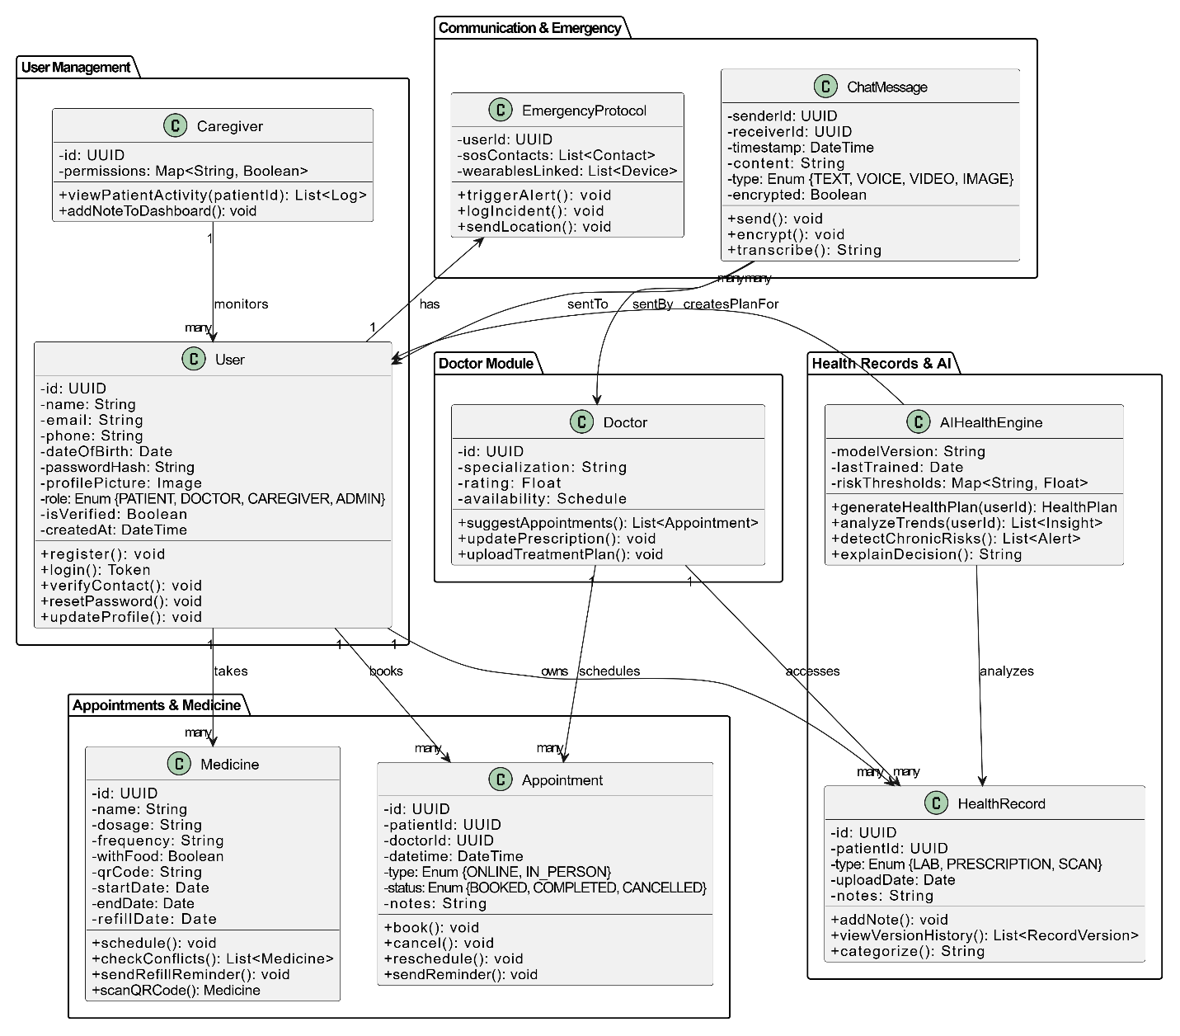

Activity Diagram
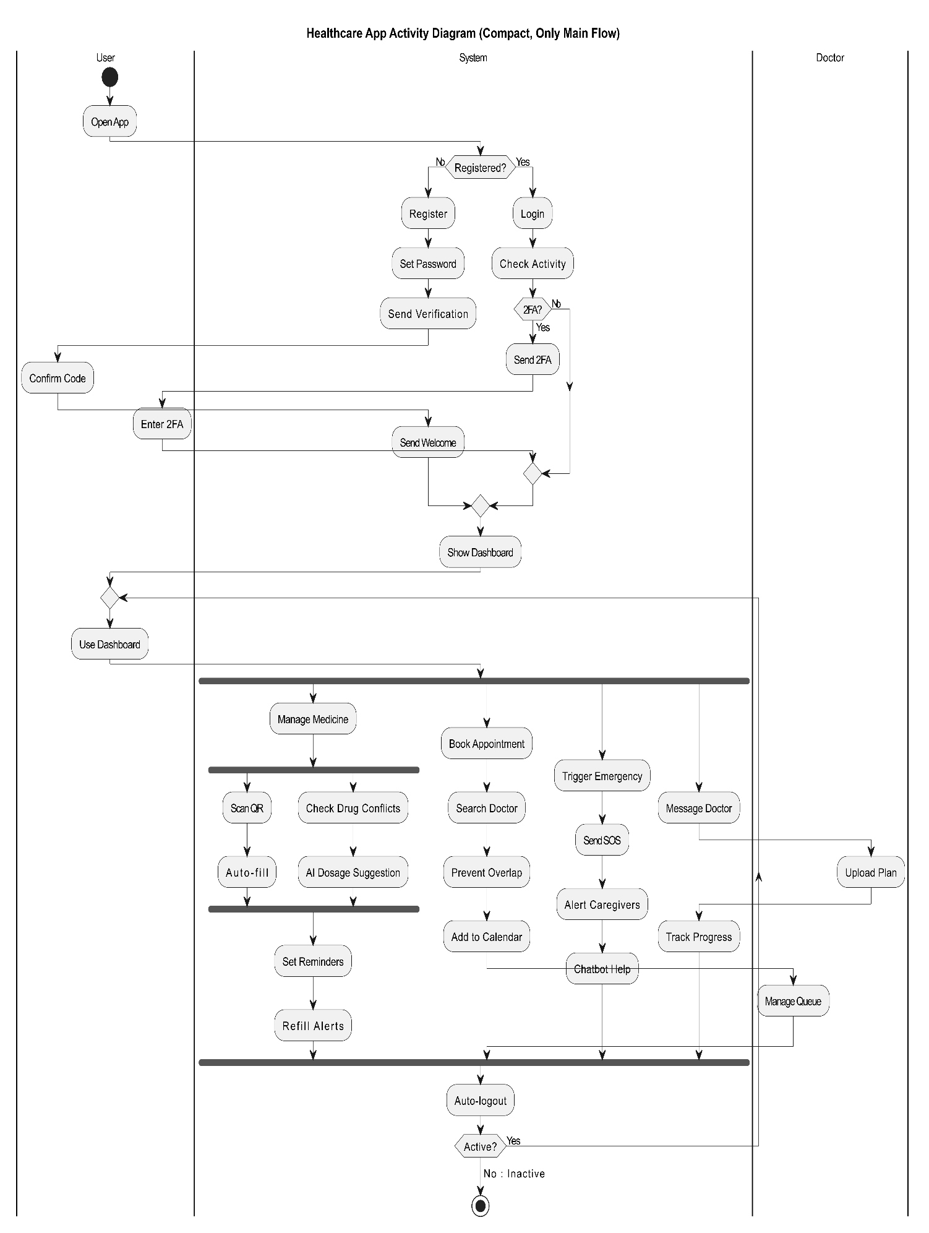

- Sequence Diagram

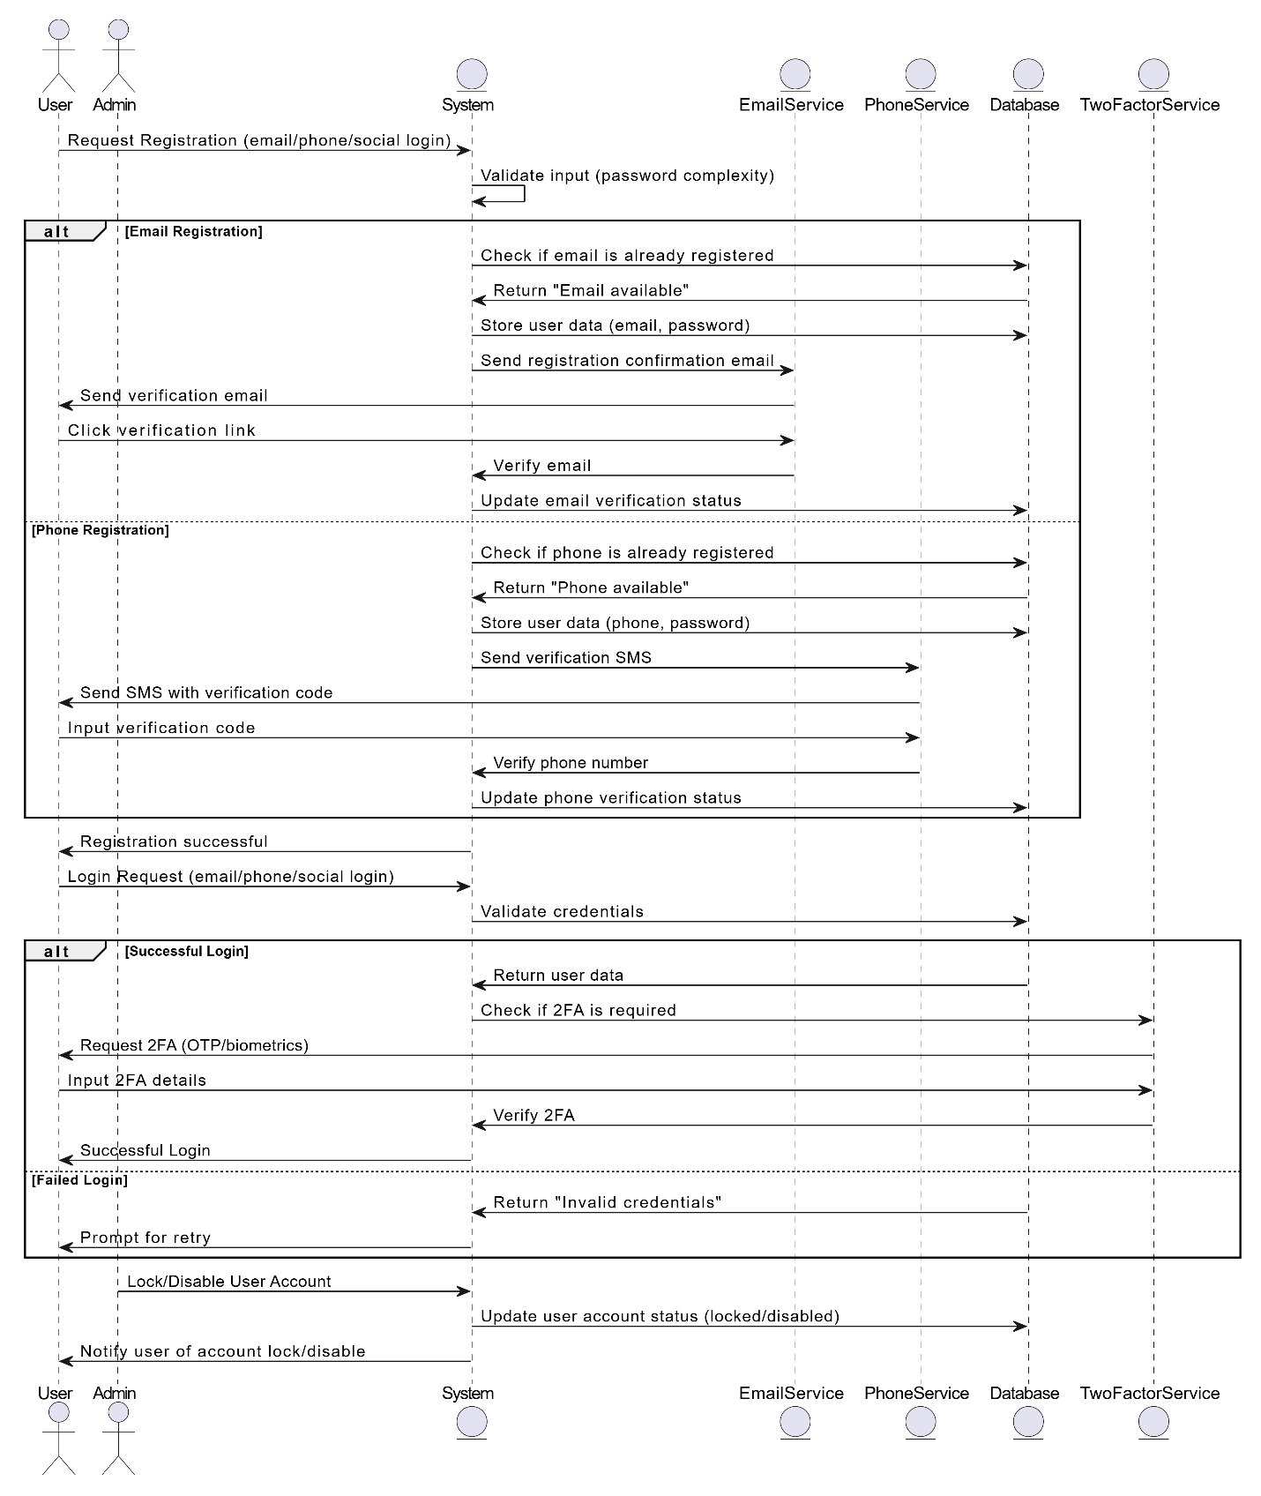
- Use Case Diagram
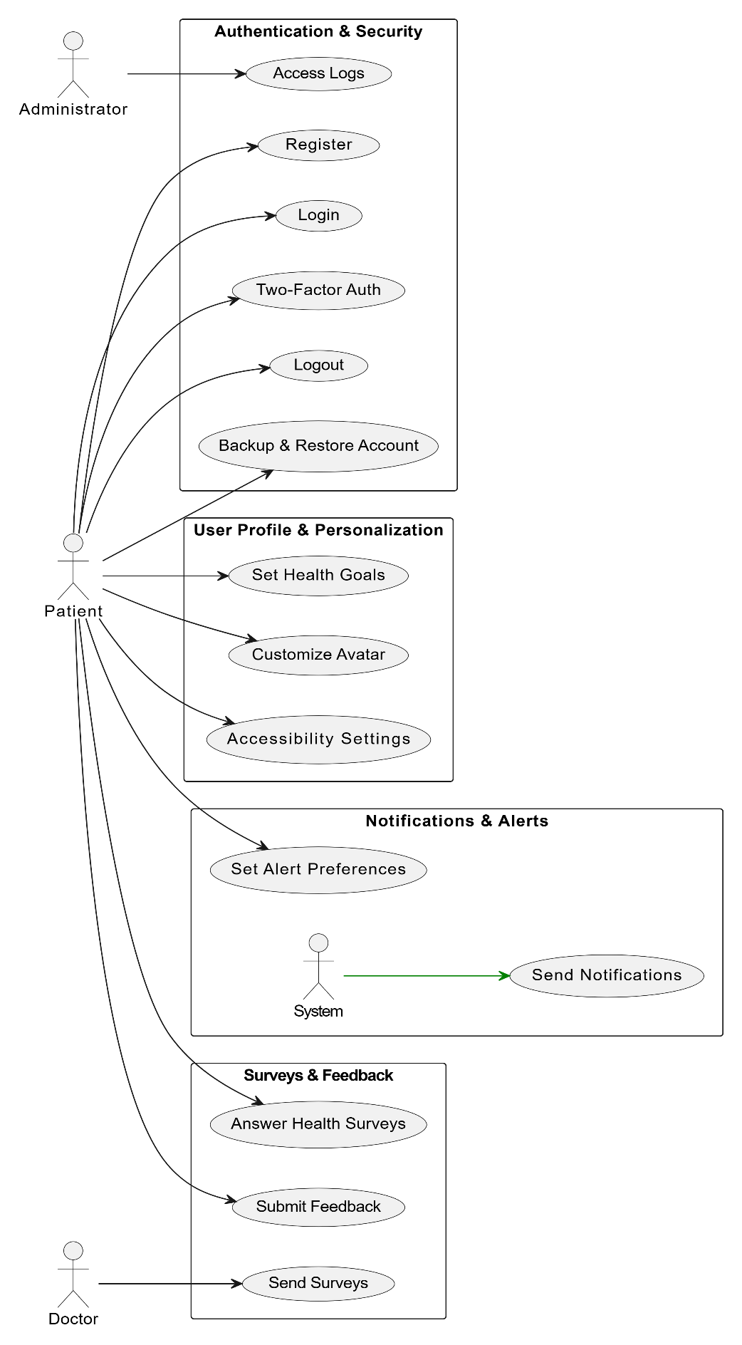
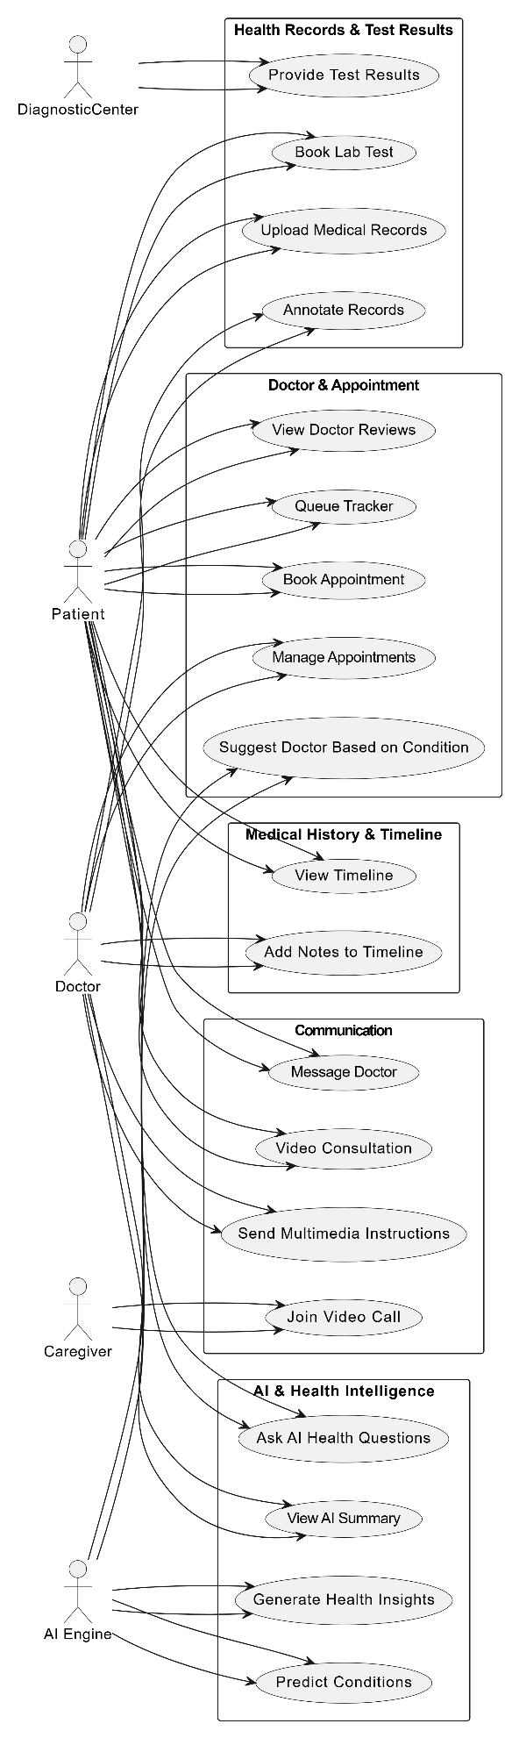
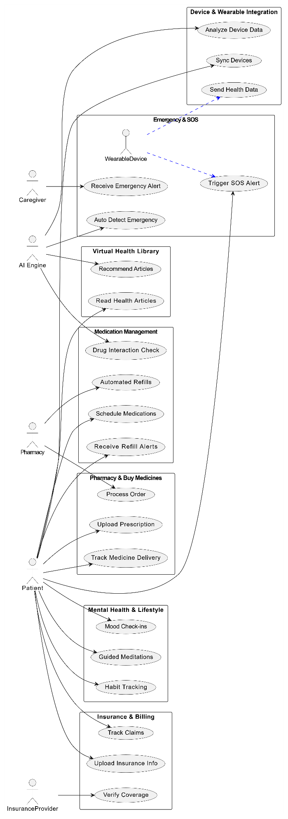

UI/UX Design:

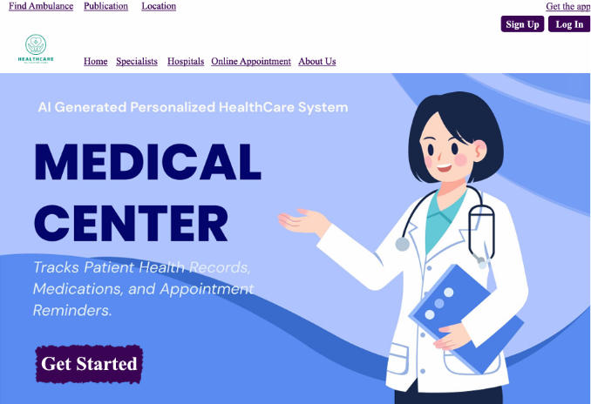

1. Home Page

This is the first page users see. It gives quick access to important healthcare services like finding an ambulance, finding a hospital, and booking an appointment. At the top, there are helpful buttons like About Us, Specialists, and Get the App. The logo can also be clicked to go back to this page. There are also Sign Up, Log In, and Get Started buttons to help users begin using the app. Everything is simple and easy to find.

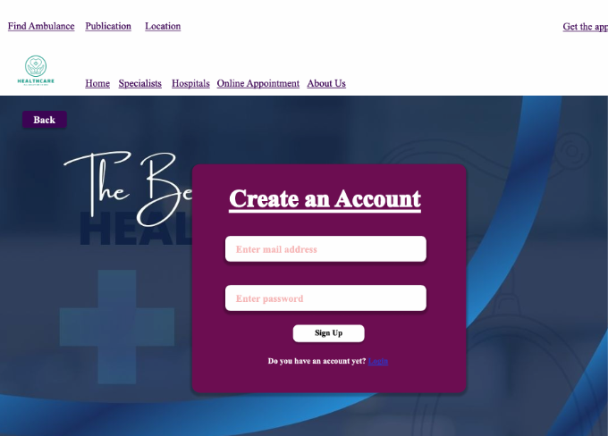

2. Sign-Up Page

This page is for new users to make an account. They just need to enter their email and password. If they already have an account, there's a message that tells them to go to the login page instead. There's also a back button to return to the last page. The top buttons are the same as on the home page.

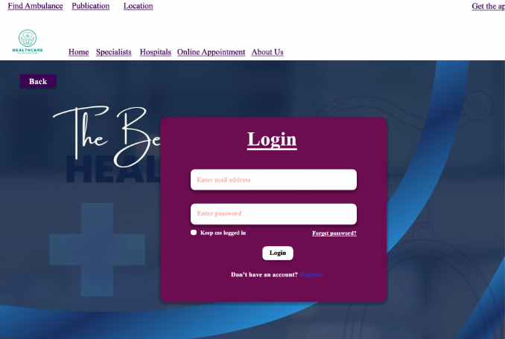

3. Login Page

This page lets users who already have an account log in by entering their email and password. It also has extra options like “Forget password?” and “Keep me logged in.” If users don’t have an account, there’s a link to go to the sign-up page. The top buttons are the same as on the home page.

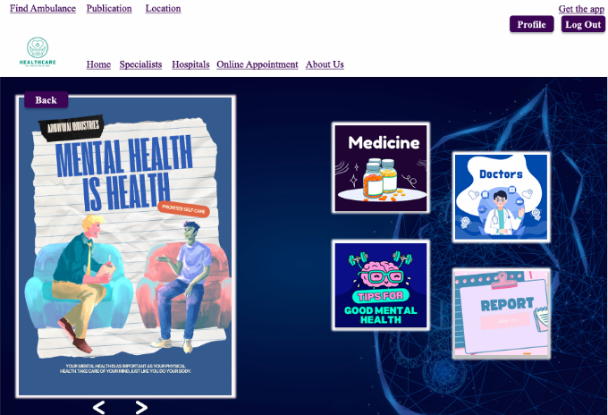

4. Profile Page

After logging in, users can see their personal profile. From here, they can check their health records, medicine list, saved doctors, and health tips. They can also manage their appointments. The page is simple and focuses on things the user needs. The top buttons are the same as on the home page.

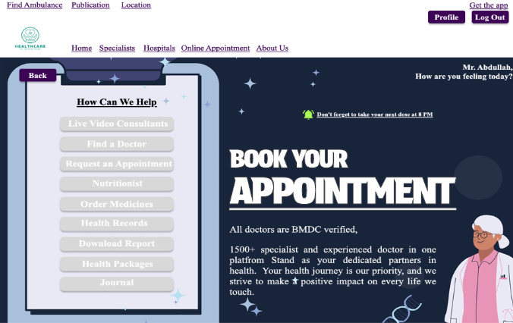

5. Dashboard

This page greets the user by name (like “Mr. Abdullah, how are you feeling today?”). It reminds them to book an appointment and shows a section called How Can We Help with useful buttons like: Live Video Chat, Find Doctor, Nutritionist, Order Medicines, Health Records, Download Report and Journals. It also says that all doctors are BMDC-verified, which helps users trust the service. There is a small reminder like: “Don’t forget to take your next dose at 8 PM.” The top buttons are the same as on the home page.
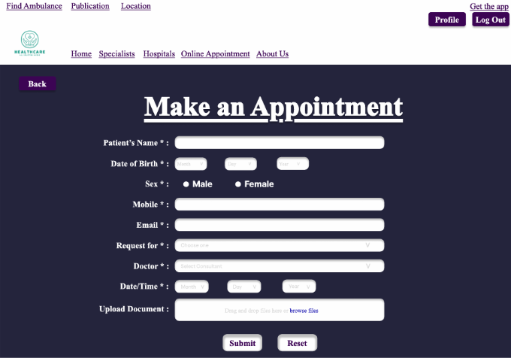

6. Appointment Booking Page

This page helps users book an appointment. It has a form where users fill in their name, date of birth, gender, phone number, email, and the doctor they want to see. They can choose a date and time, and also upload documents. There are Submit and Reset buttons at the bottom. The top buttons are the same as on the home page.
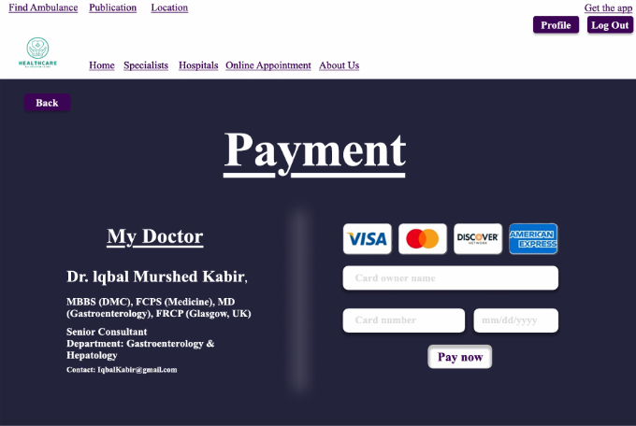

7. Payment Page

This page is for making payments. Users enter their card number, cardholder name, and expiration date, then click a Pay Now button. There is also a section called My Doctor which shows the doctor’s name, degrees, department, and contact email. The top buttons are the same as on the home page.
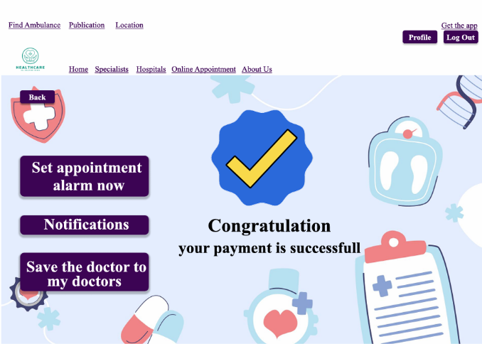

8. Confirmation Page

After finishing a payment or booking, this page shows a message like: “Congratulations, your payment is successful.” It lets the user know everything went well. There are three buttons on this page: Set Appointment Alarm, Notifications and Save the Doctor to My Doctors. The top buttons are the same as on the home page.
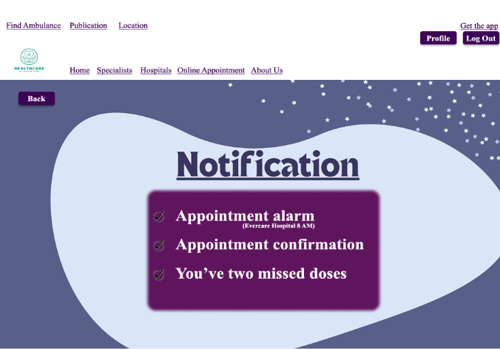

9. Notifications Page
This page shows reminders and alerts. For example, it might say: “Don’t forget to take your next dose at 8 PM,” or show alarms for upcoming appointments. It helps users stay on track with their health. The top buttons are the same as on the home page.

TEST PLAN

Description
This test plan is for the project titled "Personalized Healthcare Assistant", a smart system designed to help patients manage their health more efficiently. With features like digital health records, medicine reminders, appointment scheduling, emergency alerts, and AI-driven health suggestions, this system aims to improve the overall healthcare experience.
The goal of this test plan is to make sure everything in the system works as expected, is secure, easy to use, and reliable especially in real-life situations where health can’t wait.

Test Plan by : Software Quality Esurance Engineer Purpose of Testing

Purpose of Testing:

- Make sure all features (like medicine alerts or AI suggestions) work properly.
- Check that users’ private health data stays safe and protected.
- Confirm that the system is easy to use on different devices (phones, tablets, desktops).
- Ensure it performs smoothly under real usage conditions.
- Catch and fix bugs before users experience them.

Involved Peoples: 5 Members of the project

Testing Approach:
We're using a Black Box Testing approach. That means:
- We’ll test the system from a user’s perspective, without looking at the actual code.
- We’ll focus on what the system does, not how it does it.
- We’ll test all the main features by giving different types of inputs and checking if the output is correct.
- We’ll also test edge cases like what happens if a user skips medicine or enters wrong data
.

Test Case

Project Name: Personalized Healthcare Assistant |  |  | Test Designed by: Abdullah Al Tasnim
Test Case ID: 01 |  |  | Test Designed date: 06 May, 2025
Test Priority (Low, Medium, High): High |  |  | Test Executed by: Name
Module Name: User Registration |  |  | Test Execution date: date
Test Title: Verify user registration via email, phone number, and social logins
Description: Verify that users can register using email, phone number, or social logins.
Precondition: User is not already registered with the system
Dependencies:
Test Steps | Test Data | Expected Results |  | Actual Results | Status (Pass/Fail)
1. Go to the registration page  2. Enter username  3. Enter valid email and password  4. Click submit button  5. Enter valid phone number | 1. -  2. Abdullah  3. Email: test@example.com  Password: Abc@1234  4. Click button  5. Phone: 1234567890 | 1. Registration page is displayed.  2. Valid name  3. User proceeds to email verification step.  4. Go to dashboard  5. User receives OTP for phone verification |  | 1.Registration page is displayed  2. Username accepted  3. User proceeds to email verification step  4. Form submission failed due to server error  5. User receives OTP for phone verification | 1. Pass  2. Pass  3. Pass  4. Fail  5. Pass
Post Condition: User account is created with verified email/phone or via third-party login and stored in the database.

Project Name: Personalized Healthcare Assistant |  |  | Test Designed by: Abdullah Al Tasnim
Test Case ID: 02 |  |  | Test Designed date: 06 May, 2025
Test Priority (Low, Medium, High): High |  |  | Test Executed by:
Module Name: User Login & Security |  |  | Test Execution date:
Test Title: Verify user login and security features
Description: Test user login methods and system security measures related to authentication and account protection.
Precondition: User account already exists and is verified.
Dependencies: Third-party integrations (Google, Apple), admin controls, OTP service.
Test Steps | Test Data | Expected Results |  | Actual Results | Status (Pass/Fail)
1. Go to login page Enter username  2. Log in using valid email and password  3. Log in using valid phone number  4. Log in using Google or Apple  5. Log in successfully and check login history  6. Admin disables user account | 1. -  2. Email: user@example.com  Password: Abc@1234  3. 01789654123  4. Valid social account credentials  5. Logged-in session  6. Admin portal access | 1. Login page is displayed  2. User is successfully logged in and redirected to the dashboard  3. User is successfully authenticated using OTP  4. User is authenticated and logged in  5. System logs login timestamp, device/IP info in user profile or audit log  6. User cannot log in; message displayed: “Account disabled, contact support” |  | 1. Login page is displayed  2. User is successfully logged in and redirected to the dashboard  3. User is successfully authenticated using OTP  4. User is authenticated and logged in via social log  5. System logs login timestamp, device/IP info  6. User cannot able to log in; restriction applied here. | 1. Pass  2. Pass  3. Pass  4. Pass  5. Pass  6. Fail
Post Condition: User is authenticated securely; login attempts and activity are logged; session is secured with timeout and 2FA where applicable.

Project Name: Personalized Healthcare Assistant |  |  | Test Designed by: Abdullah Al Tasnim
Test Case ID: 03 |  |  | Test Designed date: 06 May, 2025
Test Priority (Low, Medium, High): Medium |  |  | Test Executed by:
Module Name: Medicine |  |  | Test Execution date:
Test Title: Verify medicine management features
Description: Test medicine scheduling, interaction checking, AI analysis, refill alerts, and QR-based automation
Precondition: User is logged in and has a valid medical profile
Dependencies: AI analytics engine, drug database, QR scanner, notification system
Test Steps | Test Data | Expected Results |  | Actual Results | Status (Pass/Fail)
1. Navigate to “Medicine” section  2. Create a custom schedule for a medicine  3. Add two conflicting medicines  4. Scan medicine QR code on packaging | 1. Click medicine button  2 .Med: Paracetamol, Time: 8 AM, Duration: 5 days  3. Med A: Warfarin, Med B: Aspirin  4. Valid QR containing medicine details | 1. User sees medicine management options  2. Schedule saved; reminders are activated  3. System alerts user of potential drug conflict based on patient health data  4. Fields auto-filled with name, dosage, timing, etc. |  | 1. User sees medicine management options  2. Schedule saved; reminders activated  3. System alerts user of potential drug conflict  4. Fields auto-filled with correct medicine info | 1. Pass  2. Pass  3. Pass  4. Pass
Post Condition: Custom medicine plans are active, interactions are checked, patterns are recorded by AI, reminders and alerts function as expected.

Project Name: Personalized Healthcare Assistant |  |  | Test Designed by: Abdullah Al Tasnim
Test Case ID: 04 |  |  | Test Designed date: 06 May, 2025
Test Priority (Low, Medium, High): High |  |  | Test Executed by:
Module Name: Appointment |  |  | Test Execution date:
Test Title: Verify appointment booking and smart scheduling features
Description: Test smart scheduling, doctor suggestions, filtering options, and appointment type selection.
Precondition: User and doctor accounts are registered and active
Dependencies: Calendar service, doctor availability data
Test Steps | Test Data | Expected Results |  | Actual Results | Status (Pass/Fail)
1. Attempt to book overlapping appointments  2. Doctor sends appointment suggestion to a patient  3. Patient filters doctors by specialty and availability  4. Select appointment type during booking | 1.Time slot already booked  2. Doctor selects time and patient  3. Specialty: Cardiology  Location: Dhaka  4. Option: Online or In-person | 1. System prevents double-booking; shows warning message  2. Patient receives appointment suggestion notification  3. List shows only available cardiologists in Dhaka  4. System saves selected appointment type and confirms booking |  | 1. System allowed double-booking without warning  2. Patient receives suggestion notification  3. List shows only available cardiologist in Dhaka  4. System saves selection and confirms booking | 1. Fail  2. Pass  3. Pass  4. Pass
Post Condition: Appointments are scheduled without conflicts; relevant data is stored; patient preferences and doctor suggestions are respected.

Project Name: Personalized Healthcare Assistant |  |  | Test Designed by: Abdullah Al Tasnim
Test Case ID: 10 |  |  | Test Designed date: 06 May, 2025
Test Priority (Low, Medium, High): Medium |  |  | Test Executed by:
Module Name: Health Records |  |  | Test Execution date:
Test Title: Verify health record upload, categorization, version control, and summary features
Description: Test uploading of documents, doctor annotations, versioning, categorization, summary requests, and duplicate/outdated record detection.
Precondition: User is logged in; patient profile is active
Dependencies: Document storage system, timestamping service, file parser
Test Steps | Test Data | Expected Results |  | Actual Results | Status (Pass/Fail)
1. Upload health document in supported formats  2. Doctor adds note to a specific record  3. Upload a new version of an existing health record  4. View health records by category  5. Patient requests a summary of all records | 1. File types: PDF, JPG, PNG  2. Note: “Repeat blood test in 1 week”  3. Same file name with updated content  4. Uploaded: lab test, scan, prescription  5. Click on “Generate Summary” | 1. Files are uploaded and saved to the patient's health record  2. Note is saved with timestamp and doctor ID  3. System maintains version history and allows access to previous versions  4. Records are grouped accordingly under relevant categories  5. System compiles and provides a downloadable summary (PDF or view in-app) |  | 1.Files are uploaded and saved  2.Note saved with timestamp and doctor ID  3.Old version overwritten instead of versioned  4.Records grouped correctly under relevant categori  5.Summary generated and available in-app/PDF | 1.Pass  2.Pass  3.Fail  4.Pass  5.Pass
Post Condition: Records are correctly uploaded, versioned, categorized, and accessible. Flags and summaries help users manage health information effectively.

Project Name: Personalized Healthcare Assistant |  |  | Test Designed by: Md. Arshad Islam
Test Case ID: 31 |  |  | Test Designed date: 05 May, 2025
Test Priority (Low, Medium, High): High |  |  | Test Executed by:
Module Name: Health Notes |  |  | Test Execution date:
Test Title: : Voice-to-Text Health Notes with Multi-language and Tagging Support
Description: To verify the functionality of recording health notes using voice, transcribing them to text in multiple languages, tagging, and playback capability for doctors.
Precondition: Patient is logged into the system.
Microphone permission is granted
Dependencies: Voice to text transcription service, Voice storage and playback system, Language support module
Test Steps | Test Data | Expected Results |  | Actual Results | Status (Pass/Fail)
1. Patient opens Health Notes feature. | Logged-in patient on dashboard. | Health Notes interface opens |  | Health Notes interface opens | Pass
2. Patient records a note: | Voice input (English) | Voice recorded and transcribed as text. |  | Voice is recorded but transcription in English slightly incorrect | Fail
3. Add tag "exercise" to the note. | Tag: exercise | Note is saved with tag. |  | Tag is saved correctly | Pass
4. Doctor accesses patient logs and plays the original voice. | Doctor view access | Voice clip is playable. |  | Voice clip plays successfully
5.Patient records a note in Bangla | Voice input (Bangla) | Transcription is accurate and in Bangla. |  | Bangla transcription is not accurate; mixed language output | Fail
Post Condition: Voice and text notes are saved, Doctor can listen to recordings, Tags are stored with entries.

Project Name: Personalized Healthcare Assistant |  |  | Test Designed by: Md. Arshad Islam
Test Case ID: 30 |  |  | Test Designed date: 05 May, 2025
Test Priority (Low, Medium, High): High |  |  | Test Executed by:
Module Name: Dosage Form |  |  | Test Execution date:
Test Title: Verify doctor can select and prescribe specific dosage form
Description: : Test the functionality that allows a doctor to select and prescribe dosage forms during prescription creation.

Precondition: Doctor is logged in and is creating or editing a prescription for a patient.
Dependencies: Patient profile should be available in the system.

Test Steps | Test Data | Expected Results |  | Actual Results | Status (Pass/Fail)
1. Go to prescription form |  | Prescription form is loaded |  | Prescription form loads | Pass
2. Select patient | Patient: sakib | Patient details appear on screen |  | Patient Sakib's details shown | Pass
3 Choose medicine | Medicine: Amoxicillin | Medicine is added to prescription |  | Amoxicillin added | Pass
4. Select dosage form | Form: Capsule, Strength: 500mg, Frequency: 3 times/day, Duration: 7 days | Dosage form details are saved with the prescription |  | Capsule form, 500mg, frequency and duration saved correctly | Pass
Post Condition: Dosage form details are stored in the prescription and visible to patients and caregivers in their respective views.

Project Name: Personalized Healthcare Assistant |  |  | Test Designed by: Md. Arshad Islam
Test Case ID: 35 |  |  | Test Designed date: 05 May, 2025
Test Priority (Low, Medium, High): Low |  |  | Test Executed by:
Module Name: Offline Mode |  |  | Test Execution date:
Test Title: : Verify users can view saved records and schedules while offline
Description: Test the ability to access stored medical records and scheduled appointments without internet connectivity
Precondition: User has previously accessed and saved records/schedules while online.
Dependencies: Device must have cached data available.

Test Steps | Test Data | Expected Results |  | Actual Results | Status (Pass/Fail)
1. Disconnect device from internet | Wi-Fi and mobile data: Turned off | Device switches to offline mode |  | Device entered offline mode successfully | Pass
2. Open app | App: Smart Healthcare | App launches in offline mode |  | App launched in offline mode | Pass
3 Go to “My Records” section | Saved reports and appointment list | User can view saved records and schedules |  | “My Records” section showed saved reports and appointments | Pass
Post Condition: User successfully reviews saved data in offline mode. No sync operations are attempted until the device is online.

Project Name: Personalized Healthcare Assistant |  |  | Test Designed by: Md. Arshad Islam
Test Case ID: 37 |  |  | Test Designed date: 05 May, 2025
Test Priority (Low, Medium, High): |  |  | Test Executed by:
Module Name: Access Logs |  |  | Test Execution date:
Test Title: : Verify users can view who accessed their data with timestamps
Description: Test the ability for users to view access logs showing who accessed their data, when, and from which device.
Precondition: There has been at least one login or data access by a doctor, caregiver, or user.
Dependencies: Access log module must be enabled; users and providers must have access activity.
Test Steps | Test Data | Expected Results |  | Actual Results | Status (Pass/Fail)
1. Log in as patient | Username:  Password: | User dashboard loads |  | User logged in successfully | Pass
2. Navigate to Access Logs section | Menu → Privacy & Security → Access Logs | Access log screen loads |  | Access Logs screen loads | Pass
3. View list of access entries | Doctor: Dr.Sengupta  Caregiver: Shila (nurse) | List displays names with timestamps (e.g. Dr. Sengupta - 05 May 2025, 10:30 AM) |  | Entries show names and timestamp | Pass
4. Verify unauthorized access alert (simulated) | Simulate unauthorized device login | Alert is generated and shown to user |  | Unauthorized login simulated, but no alert shown | Fail
5. Block specific device | Action: Block | Device is blocked from future access and removed from log list |  | Device blocked from access | Pass
Post Condition: Access logs are visible with accurate timestamps. Unauthorized devices are flagged or blocked. User has full visibility and control over who accessed their data.

Project Name: Personalized Healthcare Assistant |  |  | Test Designed by: Md. Arshad Islam
Test Case ID: 33 |  |  | Test Designed date: 05 May, 2025
Test Priority (Low, Medium, High): |  |  | Test Executed by:
Module Name: Calorie Calculator |  |  | Test Execution date:
Test Title: Verify users can log meals to track daily calorie intake and view real-time feedback
Description: Test the calorie tracking system allowing users to log meals and view intake vs. burn analysis.
Precondition: User has completed profile (age, gender, weight, activity level) and is logged in.
Dependencies: AI module must be active for calorie estimation. Activity data must be available (manual or from fitness tracker).
Test Steps | Test Data | Expected Results |  | Actual Results | Status (Pass/Fail)
1. Log in as user | Username: Hasan055  Password: 1234 | Dashboard is displayed |  | User logged in and dashboard shown | Pass
2. Go to Calorie Calculator | Navigation: Menu → Wellness → Calorie Calculator | Calorie tracker interface loads |  | Calorie Calculator interface loads | Pass
3 View real-time feedback | Burned: 200 kcal (fmorning walk)  Consumed: 350kcal | Net calorie balance: +150 kcal is displayed |  | Real-time feedback shows correct burn but incorrect calorie consumed data (shows 0 kcal) | Fail
4. Doctor reviews logs | Doctor account: Dr.X@clinic.com  Patient: Hasan055 | Doctor can see patient's calorie logs and trends for dietary feedback |  | Doctor can access patient calorie logs | Fail
Post Condition: User’s daily intake is logged, real-time feedback is shown, charts are updated, and logs are accessible to the assigned healthcare provider.

Project Name: Personalized Healthcare Assistant |  |  | Test Designed by: Mahamodul Hasan Taj
Test Case ID: 12 |  |  | Test Designed date: 06 May, 2025
Test Priority (Low, Medium, High): High |  |  | Test Executed by: Name
Module Name: Specialist Doctors |  |  | Test Execution date: date
Test Title: Verify specialist doctor functionalities
Description: Test the key features related to searching, booking, consultation, and review for specialist doctors.
Precondition: User must be logged in. Specialist doctors must be available in the system.
Dependencies: Internet connection, active patient and specialist accounts
Test Steps | Test Data | Expected Results |  | Actual Results | Status (Pass/Fail)
Search for specialists by condition, location, and availability  Book a virtual or in-person consultation  Specialist updates treatment plan  Collaborate with primary doctor  Submit a rating for the specialist  Schedule follow-up appointment  Use online consultation for a specific medical issue  View full specialist profile | Condition: Cardiology Location: NYC  Specialist ID: SP101Mode: Virtual  Patient ID: PT450Progress: Stable  Primary Doctor ID: PD333  Rating: 5 stars Review: "Very helpful"  Patient ID: PT450Date: [Follow-up Date]  Issue: Skin allergy  Specialist ID: SP101 | 1.Matching specialists are listed with available slots  2.Booking confirmation is shown with relevant details  3.Treatment plan is updated in patient’s record  4.Shared updates are visible to both providers  5.Rating and review are saved and displayed  6.Appointment is saved and notification is sent  7.Patient is connected with a dermatologist virtually  8.Profile shows credentials, specialties, experience, and reviews |  | 1.Matching specialists are displayed correctly  2.Booking failed due to server timeout  3.Plan updated but not visible to the patient  4. Shared updates visible to both doctors  5. Review saved and displayed successfully  6. Appointment saved, but no notification received  7. Patient connected successfully  1  8. Profile loaded with all necessary info | 1.Pass  2.Fail  3.Fail  4.Pass  5.Pass  6.Fail  7.Pass  8.Pass
Post Condition: All actions (appointments, reviews, treatment plans) are logged and visible in the patient and doctor dashboards.

Project Name: Personalized Healthcare Assistant |  |  | Test Designed by: Mahamodul Hasan Taj
Test Case ID: 13 |  |  | Test Designed date: 06 May, 2025
Test Priority (Low, Medium, High): High |  |  | Test Executed by: Name
Module Name: Device Integrations |  |  | Test Execution date: date
Test Title: Verify health device integration and data sync features
Description: Test the synchronization, setup, and dashboard visibility of health tracking devices.
Precondition: User has a compatible wearable or health device connected via Bluetooth or an account (e.g., Fitbit, Apple Health).
Dependencies: Bluetooth enabled, health device connected, internet access for cloud-based devices
Test Steps | Test Data | Expected Results |  | Actual Results | Status (Pass/Fail)
Sync user account with a wearable like Fitbit or Apple Watch  Auto-sync a Bluetooth-enabled health device  Launch the health device setup wizard in the app  Send inactivity reminder via wearable  Collect and display time-stamped, labeled data from smart devices  Display device battery status in dashboard | 1.Device: Fitbit Versa 3  2.Device: Bluetooth BP Monitor  3.User selects “Add new device”  4.User is inactive for 1 hour  5.Step count, Heart Rate  6.Fitbit battery: 60% | 1.Account syncs successfully and confirms device connection  2.Device data is fetched automatically after connection  3.Setup wizard guides the user through pairing and calibration  4.A vibration or notification is sent to the wearable  5.Data appears with timestamp and appropriate label (e.g., “Steps”, “Heart Rate”)  6.Dashboard shows device and remaining battery percentage |  | 1.Fitbit synced and confirmed  2.Data failed to sync after pairing  3. Setup wizard crashed mid-process  4. Alert was received after 1 hour  5. Data labeled properly with timestamp  6. Data labeled properly with timestamp | 1.Pass  2.Fail  3.Fail  4.Pass  5.Pass  6.Fail
Post Condition: All actions (appointments, reviews, treatment plans) are logged and visible in the patient and doctor dashboards.

Project Name: Personalized Healthcare Assistant |  |  | Test Designed by: Mahamodul Hasan Taj
Test Case ID: 14 |  |  | Test Designed date: 06 May, 2025
Test Priority (Low, Medium, High): Medium |  |  | Test Executed by: Name
Module Name: Accessibility |  |  | Test Execution date: date
Test Title: Verify accessibility and inclusive feature support
Description: Test the accessibility features to ensure inclusivity for users with diverse needs.
Precondition: Accessibility features like screen reader, text scaling, and alternate themes are enabled on the user’s device.
Dependencies: Device support for accessibility APIs, internet for language switching if required

Test Steps | Test Data | Expected Results |  | Actual Results | Status (Pass/Fail)
Enable screen reader and navigate through the app  Trigger a voice alert for medication reminder  Change app language from settings  Enable dyslexia-friendly mode  Zoom into interface content  Try using app in offline mode | 1.Device screen reader: ON  2.Reminder set: 6 PM  3.Language: Hindi  4.Setting: Dyslexia Mode  5.Zoom gesture or  6.device setting  Network: OFF | UI elements are read aloud when focused  Alert is announced via voice through device speaker  App switches to selected language without restarting  Font and contrast are adjusted to dyslexia-friendly layout UI scales  properly and remains usable without distortion  Core features like medication list and profile are still accessible |  | 1.Elements read aloud clearly  2.Alert voiced correctly  3. App language switched without issues  4. Layout adjusts for accessibility  5. Zoom works without distortion  6. Core features accessible | 1.Pass  2. Pass  3. Pass  4. Pass  5. Pass  6. Pass
Post Condition: App retains user accessibility settings and remains functional in adjusted modes.

Project Name: Personalized Healthcare Assistant |  |  | Test Designed by: Mahamodul Hasan Taj
Test Case ID: 15 |  |  | Test Designed date: 06 May, 2025
Test Priority (Low, Medium, High): High |  |  | Test Executed by: Name
Module Name: Specialist Doctors |  |  | Test Execution date: date
Test Title: Verify legal compliance and user privacy features
Description: Test system functionalities related to data access logging, consent management, and privacy settings.
Precondition: User is logged into the app. Personal health records and privacy settings are available in the system.
Dependencies: Data logging system, consent form integration, notification service
Test Steps | Test Data | Expected Results |  | Actual Results | Status (Pass/Fail)
Access personal health data  Submit a legal consent form digitally  Edit privacy settings  Allow consent to expire and check alert | 1.Module: Health Records  2.Consent Form: Telehealth Agreement  3.Change: Share data with third-party: OFF  4.Consent valid until: [Yesterday’s Date] | User receives an alert notifying consent has expired  Access is logged with timestamp and user ID  Form is stored securely and marked as verified with timestamp  Privacy settings are updated and reflected in user profile |  | 1.Access was logged correctly  2.Form submission failed with error 500  3.Settings updated successfully  4.Alert not triggered on expiry | 1.Pass  2.Fail  3.Pass  4.Fail
Post Condition: User receives an alert notifying consent has expired

Project Name: Personalized Healthcare Assistant |  |  | Test Designed by: Mahamodul Hasan Taj
Test Case ID: 16 |  |  | Test Designed date: 06 May, 2025
Test Priority (Low, Medium, High): High |  |  | Test Executed by: Name
Module Name: Mental Health & Well-being |  |  | Test Execution date: date
Test Title: Verify specialist doctor functionalities
Description: Test the features that support users' mental well-being through reminders, AI insights, exercises, and support tools.
Precondition: User is logged in with a basic profile set up.
Dependencies: AI module, push notification service, internet connection for content access
Test Steps | Test Data | Expected Results |  | Actual Results | Status (Pass/Fail)
1.Receive daily mood check-in reminder  2.View system-suggested stress relief methods  3.Access guided breathing and meditation exercises  4.AI analyzes behavior for early signs of mental health issues  5.Join anonymous mental health support group  6.Fill out and save a depression/anxiety self-assessment questionnaire | 1.Time: 9:00 AM  2.Mood: Stressed  3.Section: Mindfulness Library  4.Pattern: Low mood entriesover 7 days  5.Group: Anxiety Support  6.Tool: PHQ-9 or GAD-7 | 1.Users receive a gentle prompt to log their mood  2.The system displays personalized suggestions (e.g., rest, music, breathing)  3.Users can start audio/video sessions for breathing and meditation  4.User joins chat/forum anonymously and can 5.participate without revealing identity  6.Questionnaire is completed and securely saved in user's mental health log |  | 1.Prompt received on time  2.Personalized suggestions displayed  3.Exercises launched and functioned  4.Early warning behavior pattern detected  5.User joined anonymously and interacted  6.Questionnaire completed and saved | 1.Pass  2.Pass  3.Pass  4.Pass  5.Pass  6.Pass
Post Condition: User interactions and insights are recorded securely. Support content is accessible for ongoing mental wellness.

Project Name: Personalized Healthcare Assistant |  |  | Test Designed by: Omar Faruq Mirdha Hemal
Test Case ID: 20 |  |  | Test Designed date: 15 May, 2025
Test Priority (Low, Medium, High): High |  |  | Test Executed by: Name
Module Name: Test Booking |  |  | Test Execution date: date
Test Title: Verify a lab test using geographic location, filter, doctor's recommendation, and attached map.
Description: Test Booking functionality works and how it improves the patient's experience by integrating geolocation, doctor recommendations, insurance compatibility, and other useful features.
Precondition: Ensure that all necessary requirements such as user authentication, location access, and integration with services are met so that the system can effectively implement the described functionality.
Dependence:
Test Steps | Test Data | Expected Results |  | Actual Results | Status (Pass/Fail)
User logs in and navigates to the Book Lab Test section  System request’s location access and displays nearby trusted diagnostic centers  User applies filters for test availability, ratings, and distance  System highlights centers that are doctor-recommended and match the user's insurance or preferences  User selects a diagnostic center, clicks Get Directions, and confirms booking | Patient Name  Location (Geolocation)  Lab Test  Doctor Recommended Lab  Booking Date & Time | 1.Test booking interface loads successfully  2. User sees a list of nearby, verified centers  3. List updates to match selected filters  4. Relevant suggestions are shown with appropriate tags  5. Map shows directions, and booking is confirmed
Post Condition: The selected doctor-recommended lab is booked and logged into the system.

Project Name: Personalized Healthcare Assistant |  |  | Test Designed by: Omar Faruq Mirdha Hemal
Test Case ID: 21 |  |  | Test Designed date: 15 May, 2025
Test Priority (Low, Medium, High): High |  |  | Test Executed by: Name
Module Name: Test Results |  |  | Test Execution date: date
Test Title: Validation of Test Results Upload, Notification, Viewing, Doctor Comments, and PDF Download with Graphical Report"
Description: This test case verifies the complete workflow for managing test results within the system and this test ensures both functional accuracy and a smooth user experience across the test result module.
Precondition: A valid user and doctor account exist in the system.
Dependence:
Test Steps | Test Data | Expected Results |  | Actual Results | Status (Pass/Fail)
Admin uploads a test result file with metadata (type: "Blood Test", date: "Y-M-D").  The system automatically sorts the result by type and date.  User receives a notification indicating a new test result is available  User logs in and navigates to the test results page.  User views the test result.  Doctor logs in and adds a comment or recommendation to the result.  User sees the doctor's comments in the result details.  User clicks "Download PDF" and successfully downloads the report. | Test Result File  User Data (Patient)  Doctor Data  Expected Comment by Doctor  Graphical Report Data | The test result is visible, sorted correctly by type/date  Notification is sent and received by the user  Doctor can access the result and save a comment  Users can view the doctor’s input on the result page  User can download the report as a PDF  Graphs and visual data representations are shown clearly
Post Condition: Result is stored, viewable, and downloadable by the user at any time and Doctor's comments are associated with the result.

Project Name: Personalized Healthcare Assistant |  |  | Test Designed by: Omar Faruq Mirdha Hemal
Test Case ID: 22 |  |  | Test Designed date: 15 May, 2025
Test Priority (Low, Medium, High): High |  |  | Test Executed by: Name
Module Name: Medical History |  |  | Test Execution date: date
Test Title: Validate functionality of Medical History timeline with filtering, event linking, note-taking, and PDF export
Description: Verify the medical history timeline displays a chronological view of key health events such as visits, diagnoses, and tests, allows filtering by year and event type, provides access to detailed records, enables doctors to add notes, and supports downloading the timeline as a PDF.
Precondition: User (patient or doctor) is logged in and medical records (visits, diagnoses, tests) exist for multiple years
Dependence:
Test Steps | Test Data | Expected Results |  | Actual Results | Status (Pass/Fail)
Navigate to the Medical History section  Verify event types shown (e.g., doctor visits, diagnoses, lab tests)  Click on filter dropdown and select a specific year (e.g., 2025)  Select a filter for type (e.g., only "Diagnoses")  Click on a timeline event  (Doctor user) Add a note to an event and save  Click the "Download as PDF" button  Open the downloaded PDF | Event A: Visit – Jan 15, 2022  Event B: Diagnosis – May 10, 2023  Event C: Test – Mar 22, 2023  Doctor Note: “Patient reported mild symptoms.” | A timeline view of the user's health events is displayed  Timeline includes a variety of event types  Timeline updates to show only events from the selected year  Only diagnosis events are displayed on the timeline  A detailed view of that event is opened, with full recorded information  Note is saved and displayed with the event (verify persistence on reload)  A correctly formatted PDF of the current timeline view is generated and downloaded  PDF includes visible timeline items, filters applied, and any notes added by the doctor
Post Condition: Notes added are saved to the system and Timeline remains updated with applied filters.

Project Name: Name: Personalized Healthcare Assistant |  |  | Test Designed by: MD. OMAR FARUK
Test Case ID: 11 |  |  | Test Designed date: 13 May, 2025
Test Priority (Low, Medium, High): High |  |  | Test Executed by:
Module Name: Health Dashboard |  |  | Test Execution date:
Test Title: Verify Health Dashboard Visuals and Real-Time Updates
Description: Verify all core features of the Health Record module according to the functional requirements
Precondition: User has wearable data synced and has logged health milestones.
Dependencies:
Test Steps | Test Data | Expected Results |  | Actual Results | Status (Pass/Fail)
- Sync wearable data  - View vital trends  - Log medication  - Achieve milestone | Username: urs10  Password: 223311 | All dashboard features worked well, giving a clear and real-time view of the user’s health.
Post Condition: Dashboard updated in real time and displayed trends and achievements properly.

Work Breakdown Structure (WBS)
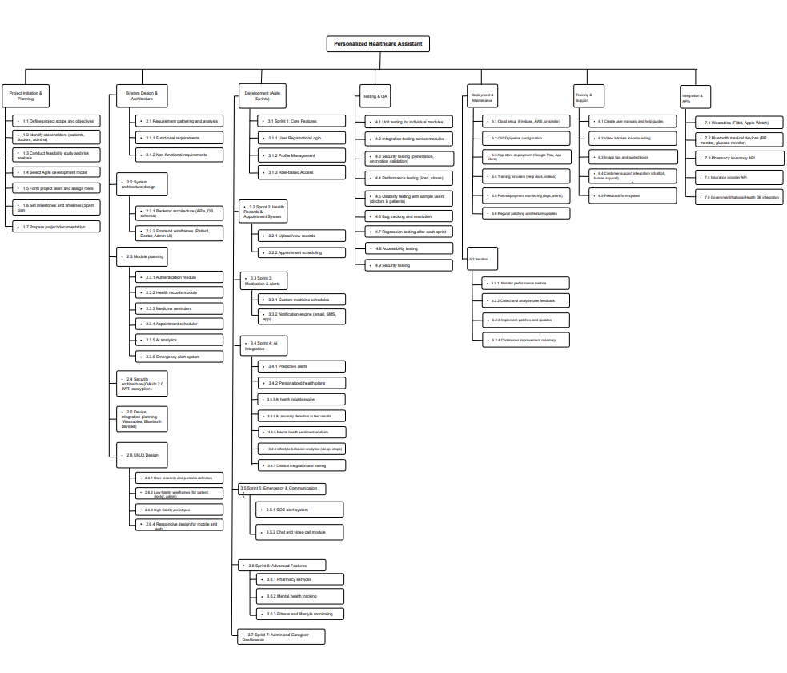

COCOMO:

1. Introduction:
The Constructive Cost Model (COCOMO) is a procedural software cost estimation model developed by Barry W. Boehm. It is used to estimate the cost, effort, and schedule when planning new software development activities. The model uses basic regression formulas with parameters derived from historical project data and current project characteristics.

2. Project Type:

Project Type: Organic
Estimated Size: 21,400 Lines of Code (SLOC)

3. Constants and Parameters:

Effort Adjustment Factor (C_{<eff>}): 2.4
Exponent (P): 1.05
Time coefficient (T): 0.38

4. COCOMO Model Calculations

4.1 Person-Months (PM):
PM = (SLOC / 1000)^P × C_{<eff>}
= (21400 / 1000)^1.05 × 2.4
≈ 59.8612 person-months

4.2 Development Months (DM):
DM = 2.5 × (PM)^T
= 2.5 × (59.8612)^0.38
≈ 11.8374 months

4.3 Staffing (ST):
ST = PM / DM
= 59.8612 / 11.8374
≈ 5 persons

Timeline Chart

Key Activity :

PP = Project Initiation & Planning
SD = System Design & Architecture
UI = UI/UX Design
DC = Development: Core Features
AF = Advanced Features

TQ = Testing & QA
DM = Deployment & Maintenance
I = Iteration
TS = Training & Support
X = Integration & APIs

Gantt Chart (Detaile Schedule)

Earn Value Analysis (EVA)
The project has 28 planned work tasks that are estimated to require 300 person-days to complete. At the time that we’ve been asked to do the earned value analysis, 8 tasks have been completed. However the project schedule indicates that 11 tasks should have been completed. The following scheduling data (in person-days) are available:
Task | Planned Effort (person-days) | Actual Effort (person-days)
1 | 12.0 | 12.5
2 | 15.0 | 16.0
3 | 5.0 | 6.5
4 | 8.0  BCWP | 6.5  ACWP
5 | 9.5 | 9.0
6 | 12.0  BCWS | 12.5
7 | 8.0 | 10.5
8 | 4.0 | 4.5
9 | 9.0 | -
10 | 13 | -
11 | 9.0 | -
BAC = 300
BCWP = 73.5
BCWS = 104.5
ACWP = 78
SPI = BCWP/ BCWS = 73.5/ 104.5 = 0.7033
SV = BCWP - BCWS = 73.5 - 104.5 = -31 person-day
CPI = BCWP/ ACWP = 73.5/78 = 0.9423
CV = BCWP – ACWP = 73.5-78 = -4.5 person-day
% schedule for completion = BCWS/ BAC = 104.5/ 300
= 34.83% [% of work scheduled to be done at this time]
% complete = BCWP/ BAC = 73.5/300 = 24.5% [% of work completed at this time]

Risk Management and Mitigation Plan (RMMM)
Risks | Category | Probability | Impact | RMMM  (Risk Monitoring & Mitigation Plan)
Security Breaches (Improper encryption, unauthorized access) | TE | 50% | 1 | Implement strong end-to-end encryption, enable multi-factor authentication, and carry out regular security audits to catch any issues early and stay ahead of potential threats.
Performance-Bottleneck (System slowdowns under heavy user load) | DE | 60% | 2 | To ensure smooth performance even during peak times, we’ll use load balancing and scalable infrastructure. This allows us to spread traffic efficiently and prevent slow response times.
Lack of proper backups (Losing critical data due to missing or outdated backups) | PR | 40% | 2 | Set up automated, versioned backups in the cloud and regularly test our disaster recovery plans. This ensures that no important data is ever lost or unrecoverable.
Emergency Handling Delays (slows or failed emergency alert) | PR | 40% | 2 | Use event-driven architecture with redundant alert channels to ensure instant and reliable emergency alert delivery.
Communication Failures (breakdowns in real-time systems) | DE | 40% | 2 | Use stable communication platforms with fallback mechanisms and real-time monitoring
Delay in third-party API integration | BU | 30% | 3 | Use mocks/stubs for early development; stay in touch with API provider.
System too large and complex | PS | 50% | 1 | Modular design, phased rollout
App downtime in emergencies (SOS fails) | BU | 10% | 1 | 99.9% uptime, offline fallback
AI gives incorrect health advice | TE | 40% | 1 | Medical-grade AI, human override, feedback loop
App difficult to use / inaccessible | CU | 30% | 2 | Usability testing, accessibility support
Poor communication with doctors/patients | CU | 30% | 2 | In-app messaging, voice notes, AI summaries
Changing or unclear requirements | PR | 40% | 2 | Agile + XP process, sprint planning
Integration failure with new devices | TE | 40% | 3 | Open standards, testing, setup guides
Limited developer experience | ST | 10% | 2 | Staff training, senior hires
Low-quality development tools | DE | 30% | 3 | Use proven frameworks, CI/CD
AI model hard to improve or adapt | TE | 40% | 3 | Explainable AI, training pipelines
Resource constraints delay testing | DE | 30% | 3 | Allocate environments early, cloud testing
Staff turnover affects progress | ST | 20% | 2 | Documentation, mentoring
Regulatory/market constraints | BU | 10% | 2 | Follow GDPR/HIPAA, privacy
Unclear stakeholder goals | CU / PR | 30% | 3 | Frequent reviews, demos
Third-party service delays | DE | 20% | 4 | Fallback modes, retry mechanisms
Insecure Device Connection | SE | 20% | 3 | Use certified APIs (HealthKit/Google Fit), enforce encryption.
Data Encryption Gaps | SE | 10% | 3 | Enforce AES-256 encryption for data at rest/in transit.
Confusing Privacy Settings | UX | 30% | 2 | Design 3-tap access for consent history, simplify toggles.
Pharmacy Info Outdated | BU | 25% | 2 | Set auto-refresh for inventory every 15 minutes.
Slow Prescription Upload or Verification | PR | 15% | 2 | Optimize image compression; auto/manual fallback for approval.
Low Accuracy of Habit Tracking | AI | 25% | 2 | Use AI anomaly checks and allow user corrections.
Slow Diagnostic Center Search | UX | 20% | 2 | Use preloaded nearby centers and progressive loading.
Inaccurate Lab Directions | DE | 20% | 2 | Use GPS fallback + location services with margin of error shown.
Slow Report Download | DE | 10% | 1 | Optimize PDF generation/rendering speed.
Missed Alerts Not Summarized | UX | 15% | 1 | Show alert summary dashboard on next login.
Unauthorized Data Access from Access Logs | TE | 40% | 2 | Regular audits of access logs and alerts for unrecognized access. Allow users to block devices instantly.
Backup Failure or Loss of Data | PR | 30% | 3 | Automate encrypted backups weekly and enable manual backup/restore options. Display cloud storage status.
AI Summary Errors Before Doctor Visits | AI | 35% | 2 | Include doctor-editable summaries and allow caregiver preview. Use past data to refine summary accuracy.
Inaccurate Chatbot Suggestions | AI | 50% | 2 | Redirect complex or emergency queries to human support. Log all interactions for doctor review.
Image Viewer Malfunctions | DE | 30% | 2 | Use secure, scalable image rendering libraries. Enable manual override and doctor annotations.
Health Challenge Cheating or System Abuse | BU | 20% | 1 | Use device sync validation for challenge tracking. Periodic challenge audits to ensure fairness.
Queue Mismanagement or Estimation Errors | UX | 25% | 2 | Allow doctors to update queue status manually. Notify patients of real-time changes via push alerts.
Confusing Onboarding for First-Time Users | UX | 40% | 1 | Use adaptive onboarding with AI tips. Let users skip, repeat, or customize tutorial steps anytime.

